Single Area OSPF

Refer to the following YouTube Video:

<https://www.youtube.com/watch?v=OWhAhFTIbDk&list=PLMLm7-g0V0kdkzbfJS-naBrLMQNDubT8p&index=15>

# Topology

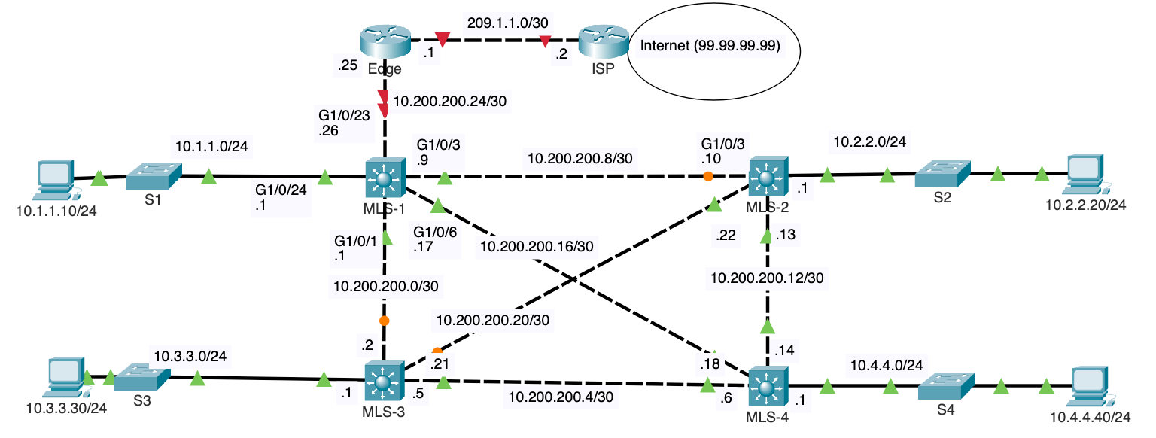

In this lab, we are working with a network topology that includes two Cisco 4331 routers and four Cisco 4332 Layer 3 switches. The current configuration utilizes Spanning Tree Protocol (STP) on the links between the Layer 3 switches to prevent network loops, which results in some ports being blocked to maintain a loop-free topology. Our goal in this lab is to convert these Layer 2 links into Layer 3 routed ports. This will eliminate the need for STP on these links, allowing for more efficient routing and potentially improving network performance. By making these ports routed, each link will be assigned an IP address, enabling OSPF to route traffic dynamically across the network. This setup will also simplify network management by treating these links as point-to-point connections, avoiding the complexities of bridging and STP configurations.

# Router (Multilayer or Layer 3 Switches) Pre-configs

The Edge, ISP, MLS-1, MLS-2, MLS-3, and MLS-4 have been pre-configured with the following commands:

Device(config)# **no ip domain-lookup**

Device(config)# **line con 0**

Device(config-line)# **logging synchronous**

Device(config-line)# **exec-timeout 0 0**

# PC Pre-configs

The PCs have been configured with static IP addressing information including their local router (L3 switch) as their default gateway address.

# Open Shortest Path First (OSPF)

Open Shortest Path First (OSPF) is a robust, link-state routing protocol widely used in Internet Protocol (IP) networks. Developed as a replacement for the older distance-vector routing protocol RIP, OSPF efficiently calculates the shortest path to each network destination by constructing a complete map or topology of the network using link-state advertisements (LSAs) from all participating routers. As an Interior Gateway Protocol (IGP), OSPF is predominantly utilized within a single routing domain or autonomous system.

Key features of OSPF include its use of Dijkstra's algorithm for shortest path first (SPF) calculations, its ability to support both IPv4 and IPv6 networks, and its classification into different area types to optimize network traffic and resource utilization. OSPF's capability to divide a large network into hierarchical segments called areas reduces routing overhead, speeds up convergence, and confines network instability to individual areas, enhancing the overall network efficiency. OSPF ensures robust security for routing information through authentication configurations that protect against unauthorized route updates.

Overall, OSPF is dynamic, scaling well to large or complex network environments, and adapts quickly to network changes, such as link failures, by re-computing the routing paths. Its widespread implementation across various router manufacturers and compatibility with most network equipment make it a preferred choice for enterprise level networks looking to maintain efficient, accurate, and fast routing methodologies.

This lab focusses on single area OSPF. Multi-area OSPF is typically used in most networks. This is because multi-area OSPF offers several strategic advantages, primarily enhancing network scalability and efficiency. By segmenting a large OSPF deployment into multiple areas, it significantly reduces the size of the routing and link-state tables maintained on routers within each area, thereby minimizing the amount of memory and CPU resources needed for OSPF computations and LSDB maintenance. This hierarchical organization also confines topology changes to individual areas, speeding up convergence and reducing the volume of OSPF traffic network-wide, as routers in different areas do not exchange detailed topology information, only summarized routes. This structured approach ensures more stable and manageable network operations, especially in large-scale environments.

# Configure IPv4 Addresses on the Interfaces

When configuring IP addresses on an interface, it is important to understand the differences between Layer 3 switches and routers. On a Layer 3 switch, you must first convert the switchport to a routed port by using the **no switchport** command before you can assign an IP address to the interface. However, you do not need to use the **no shutdown** command, as the port is typically enabled by default.

In contrast, on a router, you do not need to use the **no switchport** command because router interfaces are already configured as routed ports by default. However, you must use the **no shutdown** command to enable the interface, as router interfaces are typically in a shutdown state by default when initially configured.

## Layer 3 Switches

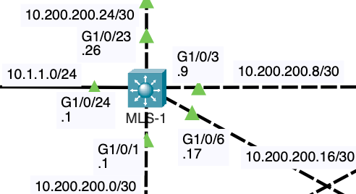

MLS-1

MLS-1(config)# **interface g1/0/1**

MLS-1(config-if)# **no switchport**

MLS-1(config-if)# **ip add 10.200.200.1 255.255.255.252**

MLS-1(config-if)# **exit**

MLS-1(config)# **interface g1/0/3**

MLS-1(config-if)# **no switchport**

MLS-1(config-if)# **ip add 10.200.200.9 255.255.255.252**

MLS-1(config-if)# **exit**

MLS-1(config)# **interface g1/0/6**

MLS-1(config-if)# **no switchport**

MLS-1(config-if)# **ip add 10.200.200.17 255.255.255.252**

MLS-1(config-if)# **exit**

MLS-1(config)# **interface g1/0/24**

MLS-1(config-if)# **no switchport**

MLS-1(config-if)# **ip add 10.1.1.1 255.255.255.0**

MLS-1(config-if)# **exit**

MLS-1(config)# **interface g1/0/23**

MLS-1(config-if)# **no switchport**

MLS-1(config-if)# **ip add 10.200.200.26 255.255.255.252**

MLS-1(config-if)# **exit**

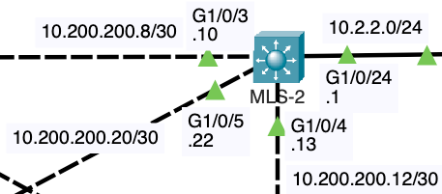

MLS-2

MLS-2(config)# **interface GigabitEthernet1/0/3**

MLS-2(config-if)# **no switchport**

MLS-2(config-if)# **ip address 10.200.200.10 255.255.255.252**

MLS-2(config-if)# **exit**

MLS-2(config)# **interface GigabitEthernet1/0/4**

MLS-2(config-if)# **no switchport**

MLS-2(config-if)# **ip address 10.200.200.13 255.255.255.252**

MLS-2(config-if)# **exit**

MLS-2(config)# **interface GigabitEthernet1/0/5**

MLS-2(config-if)# **no switchport**

MLS-2(config-if)# **ip address 10.200.200.22 255.255.255.252**

MLS-2(config-if)# **exit**

MLS-2(config)# **interface GigabitEthernet1/0/24**

MLS-2(config-if)# **no switchport**

MLS-2(config-if)# **ip address 10.2.2.1 255.255.255.0**

MLS-2(config-if)# **exit**

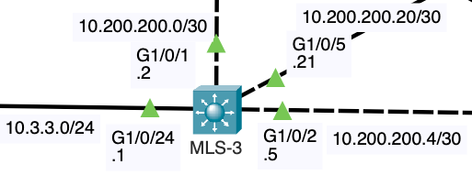

MLS-3

MLS-3(config)# **interface GigabitEthernet1/0/1**

MLS-3(config-if)# **no switchport**

MLS-3(config-if)# **ip address 10.200.200.2 255.255.255.252**

MLS-3(config)# **interface GigabitEthernet1/0/2**

MLS-3(config-if)# **no switchport**

MLS-3(config-if)# **ip address 10.200.200.5 255.255.255.252**

MLS-3(config-if)# **exit**

MLS-3(config)# **interface GigabitEthernet1/0/5**

MLS-3(config-if)# **no switchport**

MLS-3(config-if)# **ip address 10.200.200.21 255.255.255.252**

MLS-3(config-if)# **exit**

MLS-3(config)# **interface GigabitEthernet1/0/24**

MLS-3(config-if)# **no switchport**

MLS-3(config-if)# **ip address 10.3.3.1 255.255.255.0**

MLS-3(config-if)# **exit**

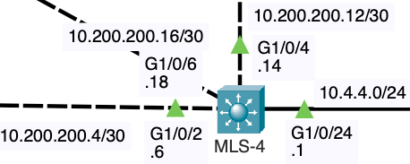

MLS-4

MLS-4(config)# **interface GigabitEthernet1/0/2**

MLS-4(config-if)# **no switchport**

MLS-4(config-if)# **ip address 10.200.200.6 255.255.255.252**

MLS-4(config-if)# **exit**

MLS-4(config)# **interface GigabitEthernet1/0/4**

MLS-4(config-if)# **no switchport**

MLS-4(config-if)# **ip address 10.200.200.14 255.255.255.252**

MLS-4(config-if)# **exit**

MLS-4(config)# **interface GigabitEthernet1/0/6**

MLS-4(config-if)# **no switchport**

MLS-4(config-if)# **ip address 10.200.200.18 255.255.255.252**

MLS-4(config-if)# **exit**

MLS-4(config)# **interface GigabitEthernet1/0/24**

MLS-4(config-if)# **no switchport**

MLS-4(config-if)# **ip address 10.4.4.1 255.255.255.0**

MLS-4(config-if)# **exit**

If all the ports on the multilayer switch will be used as routed ports, another option is to configure all with the ports with the **no switchport** command. Then individually assign the IP addressing to each port.

For example:

MLS-4(config)# **interface range GigabitEthernet 1/0/1-24**

MLS-4(config-if-range)# **no switchport**

MLS-4(config-if-range)# **exit**

MLS-4(config)# **interface GigabitEthernet1/0/2**

MLS-4(config-if)# **ip address 10.200.200.6 255.255.255.252**

## Router Configurations

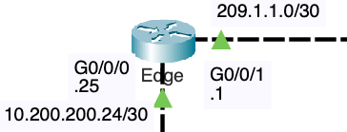

Edge Router

Edge(config)# **interface GigabitEthernet0/0/0**

Edge(config-if)# **ip address 10.200.200.25 255.255.255.252**

Edge(config-if)# **no shutdown**

Edge(config-if)# **exit**

Edge(config)# **interface GigabitEthernet0/0/1**

Edge(config-if)# **ip address 209.1.1.1 255.255.255.252**

Edge(config-if)# **no shutdown**

Edge(config-if)# **exit**

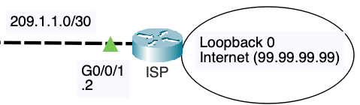

ISP Router

ISP(config)# **interface GigabitEthernet0/0/1**

ISP(config-if)# **ip address 209.1.1.2 255.255.255.252**

ISP(config-if)# **no shutdown**

ISP(config-if)# **exit**

ISP(config)# **interface Loopback0**

ISP(config-if)# **ip address 99.99.99.99 255.255.255.0**

ISP(config-if)# **no shutdown**

ISP(config-if)# **exit**

In network configurations, a loopback address can be used as a virtual address that serves various purposes. In our scenario, the ISP router has a loopback0 address configured, which will be used to represent reachability outside the OSPF routing domain. This setup is particularly useful for providing a consistent and reliable address that remains up as long as the router is operational, regardless of the state of physical interfaces.

The loopback address **99.99.99.99** provides a stable IP address that always remains up. In our case, the loopback0 address on the ISP router will represent reachability outside the OSPF routing domain. It will serve as a consistent endpoint that other routers within the OSPF domain can use to route traffic destined for networks outside the OSPF routing domain.

## Topology Change: No more STP between L3 Switches

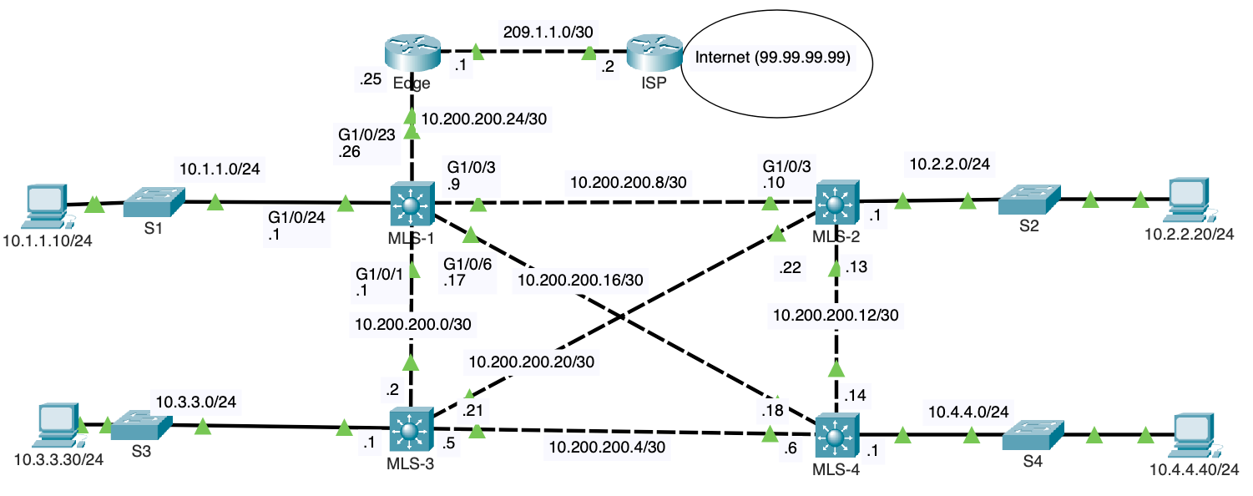

After configuring the IP addresses on all devices in the topology, the links between the Layer 3 switches are no longer running Spanning Tree Protocol (STP). This is because the ports have been converted to Layer 3 routed ports, which operate at the network layer rather than the data link layer where STP functions. As a result, STP is no longer necessary to prevent loops, and all links are now active and available for routing traffic. This change enhances the network's efficiency and performance, allowing routing protocols such as OSPF, to dynamically route traffic across the network without any blocked ports, thereby maximizing the use of available bandwidth and providing better redundancy and load balancing.

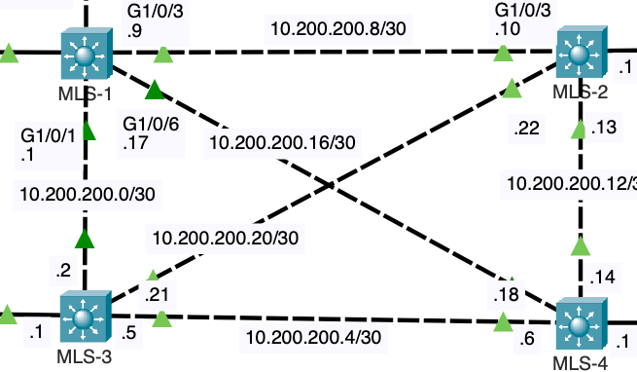

# Understanding Directly Connected Networks

Before configuring OSPF, it's essential to understand how a router (or Layer 3 switch) learns about its directly connected networks from the IP addressing (IPv4 address and subnet mask) configuration of its interfaces. This process is indicated in the output from the **show ip route** command on MLS-1, as shown below:



Examining the routing table on MLS-1

MLS-1# **show ip route**

Codes: C - connected, S - static, I - IGRP, R - RIP, M - mobile, B - BGP

D - EIGRP, EX - EIGRP external, O - OSPF, IA - OSPF inter area

N1 - OSPF NSSA external type 1, N2 - OSPF NSSA external type 2

E1 - OSPF external type 1, E2 - OSPF external type 2, E - EGP

i - IS-IS, L1 - IS-IS level-1, L2 - IS-IS level-2, ia - IS-IS inter area

* - candidate default, U - per-user static route, o - ODR

P - periodic downloaded static route

Gateway of last resort is not set

10.0.0.0/8 is variably subnetted, 5 subnets, 2 masks

C 10.1.1.0/24 is directly connected, GigabitEthernet1/0/24

C 10.200.200.0/30 is directly connected, GigabitEthernet1/0/1

C 10.200.200.8/30 is directly connected, GigabitEthernet1/0/3

C 10.200.200.16/30 is directly connected, GigabitEthernet1/0/6

C 10.200.200.24/30 is directly connected, GigabitEthernet1/0/23

MLS-1#

**Note**: Packet Tracer does not include Local routes for some devices, including our 4331 switches.

From this output, we see that MLS-1 has learned about the networks 10.1.1.0/24, 10.200.200.0/30, 10.200.200.8/30, 10.200.200.16/30, and 10.200.200.24/30. Each of these networks is marked with a "C" indicating they are directly connected to specific interfaces on MLS-1. This learning occurs automatically when IP addresses and subnet masks are configured on the router's interfaces.

This process is analogous to how a computer, when assigned an IP address and subnet mask, learns which network it is connected to. For example, if a computer receives the IP address 10.1.1.10 with a subnet mask of 255.255.255.0, it recognizes that it belongs to the 10.1.1.0/24 network. Similarly, the router (or Layer 3 switch) identifies its directly connected networks based on the IP configurations of its interfaces. Understanding these directly connected networks is crucial as it forms the foundation for further dynamic routing protocols like OSPF, which will then advertise these networks to other routers in the OSPF domain.

## Understanding the Local Route

The output of the **show ip route** command includes two types of routes for each directly connected network: "C" for directly connected routes and "L" for local routes. Understanding the difference between these two is crucial for efficient routing.

Examining the routing table on Edge



Edge# **show ip route**

Codes: L - local, C - connected, S - static, R - RIP, M - mobile, B - BGP

D - EIGRP, EX - EIGRP external, O - OSPF, IA - OSPF inter area

N1 - OSPF NSSA external type 1, N2 - OSPF NSSA external type 2

E1 - OSPF external type 1, E2 - OSPF external type 2, E - EGP

i - IS-IS, L1 - IS-IS level-1, L2 - IS-IS level-2, ia - IS-IS inter area

* - candidate default, U - per-user static route, o - ODR

P - periodic downloaded static route

Gateway of last resort is not set

10.0.0.0/8 is variably subnetted, 2 subnets, 2 masks

C 10.200.200.24/30 is directly connected, GigabitEthernet0/0/0

L 10.200.200.25/32 is directly connected, GigabitEthernet0/0/0

209.1.1.0/24 is variably subnetted, 2 subnets, 2 masks

C 209.1.1.0/30 is directly connected, GigabitEthernet0/0/1

L 209.1.1.1/32 is directly connected, GigabitEthernet0/0/1

Edge#

**C - Directly Connected Route**

A "C" route indicates a directly connected network. This means that the router has an interface with an IP address belonging to that network, and it can reach any device in that network directly without needing any intermediate routing. For example, on the Edge router:

C 10.200.200.24/30 is directly connected, GigabitEthernet0/0/0

C 209.1.1.0/30 is directly connected, GigabitEthernet0/0/1

**L - Local Route**

An "L" route represents a local route, which is a host route with a /32 prefix length. This route points to the specific IP address assigned to the router's interface. For example, on the Edge router:

L 10.200.200.25/32 is directly connected, GigabitEthernet0/0/0

L 209.1.1.1/32 is directly connected, GigabitEthernet0/0/1

**Purpose of Local Routes**

The local route is included in the routing table to optimize packet handling when the router itself is the destination. For example, if you ping the router's interface IP address or establish an SSH session to it, the router can immediately match the incoming packet to the local route. This efficiency avoids unnecessary processing and ensures that the packets destined for the router's own IP addresses are handled promptly.

Examining the routing table on ISP

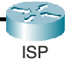

ISP# **show ip route**

Codes: L - local, C - connected, S - static, R - RIP, M - mobile, B - BGP

D - EIGRP, EX - EIGRP external, O - OSPF, IA - OSPF inter area

N1 - OSPF NSSA external type 1, N2 - OSPF NSSA external type 2

E1 - OSPF external type 1, E2 - OSPF external type 2, E - EGP

i - IS-IS, L1 - IS-IS level-1, L2 - IS-IS level-2, ia - IS-IS inter area

* - candidate default, U - per-user static route, o - ODR

P - periodic downloaded static route

Gateway of last resort is not set

99.0.0.0/8 is variably subnetted, 2 subnets, 2 masks

C 99.99.99.0/24 is directly connected, Loopback0

L 99.99.99.99/32 is directly connected, Loopback0

209.1.1.0/24 is variably subnetted, 2 subnets, 2 masks

C 209.1.1.0/30 is directly connected, GigabitEthernet0/0/1

L 209.1.1.2/32 is directly connected, GigabitEthernet0/0/1

ISP#

The ISP router's routing table includes both physical and virtual loopback interfaces to enhance network efficiency and reliability. The physical interface **GigabitEthernet0/0/1** provides connectivity to the **209.1.1.0/30** network, with its IP address **209.1.1.2/32** locally reachable, facilitating direct communication with connected devices.

The loopback interface **Loopback0**, configured with the IP address **99.99.99.99/32**, serves as a stable, virtual endpoint that remains up as long as the router is operational, providing consistent reachability for routing protocols and management tasks. This configuration ensures that packets destined for the router's interfaces are efficiently routed, whether for direct connectivity or network management, thereby optimizing overall network performance and stability.

# Basic OSPF Configuration

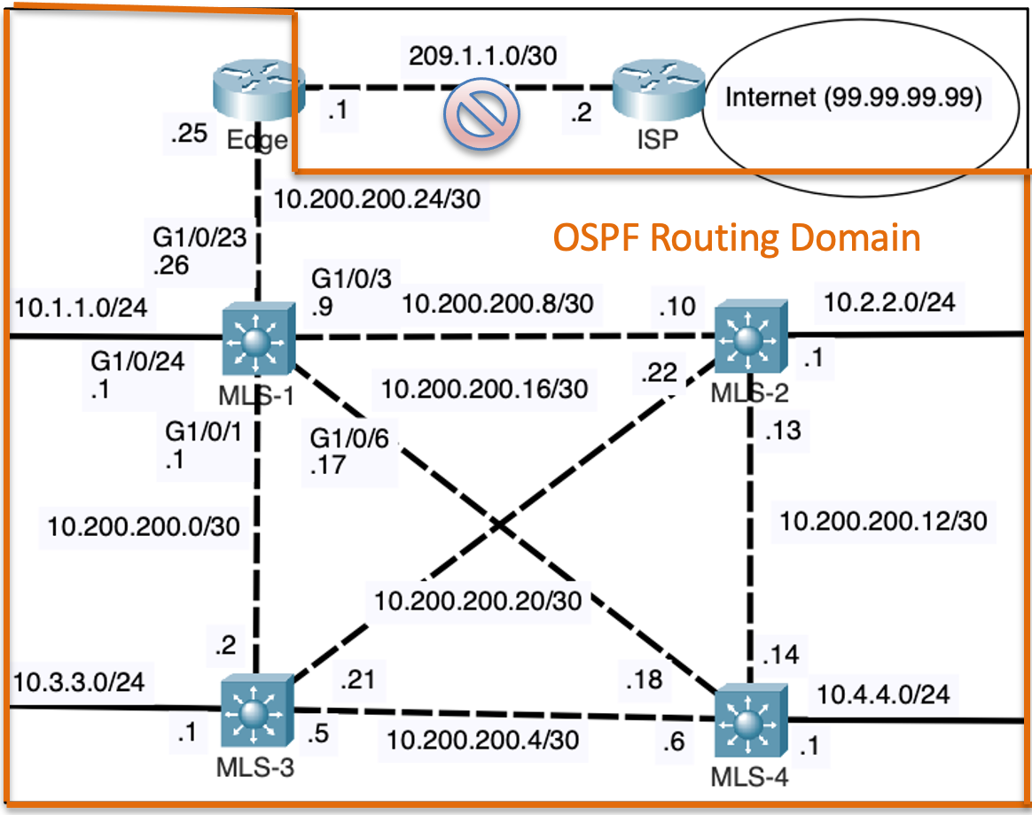

It is typical to enable an Interior Gateway Protocol (IGP) like OSPF only on internal interfaces within a network; between the Edge, MLS-1, MLS-2, MLS-3 and MLS-4 routers. This approach confines OSPF to manage internal routing efficiently. For routing between the edge router and the ISP, other methods such as static routes, a different IGP process, or Border Gateway Protocol (BGP) are commonly used. These methods provide more granular control and security for external routing, ensuring that internal routing protocols remain isolated from external influences. This separation optimizes performance and maintains a clear distinction between internal and external network management.

## Network Command and Wildcard Mask: MLS-1 and MLS-2

To configure OSPF on a Cisco device, the **network** command is used along with a wildcard mask to specify the networks that will participate in the OSPF process. The wildcard mask is derived from the subnet mask and is used to identify which bits in the IP address should be considered for the network statement.

The wildcard mask is inverse of the subnet mask. It is arrived at by using 255.255.255.255 and subtracting the subnet mask. For example, 255.255.255.255 – 255.255.255.0 results in the wildcard mask 0.0.0.255. Another example is 255.255.255.255 – 255.255.255.252 results in the wildcard mask 0.0.0.3.

Enabling OSPF on MLS-1 Interfaces using the network command and wildcard mask



MLS-1(config)# **router ospf 1**

MLS-1(config-router)# **router-id 1.1.1.1**

MLS-1(config-router)# **network 10.1.1.0 0.0.0.255 area 0**

MLS-1(config-router)# **network 10.200.200.24 0.0.0.3 area 0**

MLS-1(config-router)# **network 10.200.200.8 0.0.0.3 area 0**

MLS-1(config-router)# **network 10.200.200.16 0.0.0.3 area 0**

MLS-1(config-router)# **network 10.200.200.0 0.0.0.3 area 0**

MLS-1(config-router)# **end**

MLS-1# **clear ip ospf process**

Reset ALL OSPF processes? [no]: **yes**

MLS-1#

In the OSPF configuration shown, we are setting up OSPF on MLS-1 with a router ID and specifying the networks that will participate in the OSPF process using the **network** command and wildcard masks. The router ID is configured to **1.1.1.1** for unique identification within the OSPF domain.

The **network** commands specify the networks **10.1.1.0/24**, **10.200.200.24/30**, **10.200.200.8/30**, **10.200.200.16/30**, and **10.200.200.0/30** to be included in OSPF area 0, with the wildcard masks defining the exact range of IP addresses for each network.

After configuring the OSPF settings, it is necessary to reset the OSPF process using the **clear ip ospf process** command to apply the newly configured router ID. This step ensures that the router recognizes and uses the correct router ID for OSPF operations.

### Using the Subnet Mask Instead of a Wildcard Mask

When configuring OSPF on a Cisco device, you can use a subnet mask instead of a wildcard mask in the **network** command. For example, **network 10.2.2.0 255.255.255.0 area 0** and **network 10.200.200.8 255.255.255.252 area 0** are valid configurations. However, IOS will automatically convert and display these subnet masks as their corresponding wildcard masks in the running configuration.

### Examining the router-id with **show ip protocols**

We will discuss the show ip protocols command in more detail later. For now, notice that the OSPF process number is **“1”** that is running on the router and the **router ID** for this OSPF process is set to 1.1.1.1. The router ID uniquely identifies the router within the OSPF domain.

MLS-1# **show ip protocols**

Routing Protocol is "ospf 1"

Outgoing update filter list for all interfaces is not set

Incoming update filter list for all interfaces is not set

Router ID 1.1.1.1

Number of areas in this router is 1. 1 normal 0 stub 0 nssa

Maximum path: 4

Routing for Networks:

10.1.1.0 0.0.0.255 area 0

10.200.200.24 0.0.0.3 area 0

10.200.200.8 0.0.0.3 area 0

10.200.200.16 0.0.0.3 area 0

10.200.200.0 0.0.0.3 area 0

Routing Information Sources:

Gateway Distance Last Update

1.1.1.1 110 00:06:23

2.2.2.2 110 00:06:49

3.3.3.3 110 00:06:53

4.4.4.4 110 00:06:49

10.10.10.10 110 00:06:23

Distance: (default is 110)

MLS-1#

Enabling OSPF on MLS-2 Interfaces using the network command and wildcard mask

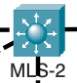

MLS-2(config)# **router ospf 1**

MLS-2(config-router)# **router-id 2.2.2.2**

MLS-2(config-router)# **network 10.2.2.0 255.255.255.0 area 0**

MLS-2(config-router)# **network 10.200.200.8 255.255.255.252 area 0**

MLS-2(config-router)# **network 10.200.200.20 255.255.255.252 area 0**

MLS-2(config-router)# **network 10.200.200.12 255.255.255.252 area 0**

MLS-2(config-router)# **end**

MLS-2# **clear ip ospf process**

Reset ALL OSPF processes? [no]: **yes**

MLS-2#

## Network Command and 0.0.0.0 Wildcard Mask: MLS-3

In the OSPF configuration on MLS-3, using the **network** command with a wildcard mask of **0.0.0.0** specifies an exact match for a single IP address rather than a range of addresses, which is different from specifying a broader network address.

Enabling OSPF on MLS-3 Interfaces using the network command and a 0.0.0.0 wildcard mask



MLS-3(config)# **router ospf 1**

MLS-3(config-router)# **router-id 3.3.3.3**

MLS-3(config-router)# **network 10.3.3.1 0.0.0.0 area 0**

MLS-3(config-router)# **network 10.200.200.2 0.0.0.0 area 0**

MLS-3(config-router)# **network 10.200.200.5 0.0.0.0 area 0**

MLS-3(config-router)# **network 10.200.200.21 0.0.0.0 area 0**

MLS-3(config-router)# **end**

MLS-3# **clear ip ospf process**

Reset ALL OSPF processes? [no]: **yes**

MLS-3#

For example, in the configuration above, **network 10.3.3.1 0.0.0.0 area 0** indicates that only the interface with the IP address **10.3.3.1** will be included in OSPF area 0. This exact matching approach ensures that only the specified interfaces (10.3.3.1, 10.200.200.2, 10.200.200.5, and 10.200.200.21) participate in the OSPF process, providing precise control over which interfaces are included.

This is different from using a more general network address with a broader wildcard mask (e.g., **network 10.0.0.0 0.255.255.255**), which would include a range of IP addresses and potentially multiple interfaces within the specified network. This configuration style is useful for environments where specific interfaces need to be managed within OSPF without including an entire subnet.

## Enabling OSPF Directly on the Interface: MLS-4

OSPF can be enabled directly on an interface by using the **ip ospf [process-id] area [area-id]** command within the interface configuration mode. This method configures OSPF for specific interfaces without using the global **network** command under the OSPF routing process.

Enabling OSPF on MLS-4 directly on the interface



MLS-4(config)# **router ospf 1**

MLS-4(config-router)# **router-id 4.4.4.4**

MLS-4(config-router)# **exit**

MLS-4(config)# **interface GigabitEthernet1/0/2**

MLS-4(config-if)# **ip ospf 1 area 0**

MLS-4(config-if)# **exit**

MLS-4(config)# **interface GigabitEthernet1/0/4**

MLS-4(config-if)# **ip ospf 1 area 0**

MLS-4(config-if)# **exit**

MLS-4(config)# **interface GigabitEthernet1/0/6**

MLS-4(config-if)# **ip ospf 1 area 0**

MLS-4(config-if)# **exit**

MLS-4(config)# **interface GigabitEthernet1/0/24**

MLS-4(config-if)# **ip ospf 1 area 0**

MLS-4(config-if)# **end**

MLS-4# **clear ip ospf process**

Reset ALL OSPF processes? [no]: **yes**

MLS-4#

In this configuration, OSPF process 1 is enabled on interfaces GigabitEthernet1/0/2, 1/0/4, 1/0/6, and 1/0/24, all within OSPF area 0. By configuring OSPF directly on the interfaces, you ensure that only the specified interfaces participate in the OSPF routing process, providing more granular control over OSPF deployment. This method is particularly useful when you want to enable OSPF on specific interfaces without defining broader network ranges.

## Enabling OSPF Only on the Internal Network: Edge

As previously mentioned, it is typical to enable an Interior Gateway Protocol (IGP) like OSPF only on internal interfaces within a network, as seen in the Edge router configuration.



Edge(config)# **router ospf 1**

Edge(config-router)# **router-id 10.10.10.10**

Edge(config-router)# **network 10.200.200.24 0.0.0.3 area 0**

Edge(config-router)# **end**

Edge# **clear ip ospf process**

Reset ALL OSPF processes? [no]: **yes**

Edge#

In the configuration of the Edge router, OSPF is enabled only on the interface connected to the internal OSPF routing domain using the **network 10.200.200.24 0.0.0.3 area 0** command. This command specifies that OSPF process 1 will operate on the interface within the **10.200.200.24/30** subnet, which connects the Edge router to the internal OSPF network. The router ID is set to **10.10.10.10** to uniquely identify this router within the OSPF domain. Later, we will configure static routes between the Edge router and the ISP to manage connectivity to external networks, ensuring that internal OSPF routes and external static routes are properly integrated.

# Verifying OSPF



Several commands are used to verify and troubleshoot OSPF.

## show ip ospf neighbor

The output of the **show ip ospf neighbor** command on MLS-1 provides a list of OSPF neighbors and their status.



MLS-1# **show ip ospf neighbor**

Neighbor ID Pri State Dead Time Address Interface

3.3.3.3 1 FULL/BDR 00:00:36 10.200.200.2 GigabitEthernet1/0/1

2.2.2.2 1 FULL/DR 00:00:39 10.200.200.10 GigabitEthernet1/0/3

4.4.4.4 1 FULL/DR 00:00:39 10.200.200.18 GigabitEthernet1/0/6

10.10.10.10 1 FULL/BDR 00:00:36 10.200.200.25 GigabitEthernet1/0/23

MLS-1#

Each entry includes the following information:

* **Neighbor ID:** The router ID of the neighboring OSPF router.
* **Pri (Priority):** The OSPF priority of the neighbor, which influences the election of the designated router (DR) and backup designated router (BDR).
* **State:** The current OSPF state with the neighbor. **FULL/DR** indicates the neighbor is the designated router, and **FULL/BDR** indicates the neighbor is the backup designated router.
* **Dead Time:** The amount of time remaining before the neighbor is declared dead if no OSPF hello packets are received.
* **Address:** The IP address of the neighbor's interface that is directly connected to MLS-1.
* **Interface:** The local interface on MLS-1 through which the neighbor is reachable.

## show ip ospf interface

The **show ip ospf interface** command provides detailed information about the OSPF configuration and status of the interface.

MLS-1# **show ip ospf interface g 1/0/3**

GigabitEthernet1/0/3 is up, line protocol is up

Internet address is 10.200.200.9/30, Area 0

Process ID 1, Router ID 1.1.1.1, Network Type BROADCAST, Cost: 1

Transmit Delay is 1 sec, State BDR, Priority 1

Designated Router (ID) 2.2.2.2, Interface address 10.200.200.10

Backup Designated Router (ID) 1.1.1.1, Interface address 10.200.200.9

Timer intervals configured, Hello 10, Dead 40, Wait 40, Retransmit 5

Hello due in 00:00:05

Index 3/3, flood queue length 0

Next 0x0(0)/0x0(0)

Last flood scan length is 1, maximum is 1

Last flood scan time is 0 msec, maximum is 0 msec

Neighbor Count is 1, Adjacent neighbor count is 1

Adjacent with neighbor 2.2.2.2 (Designated Router)

Suppress hello for 0 neighbor(s)

The output provides detailed information about the OSPF configuration and status of the interface **GigabitEthernet1/0/3** on MLS-1:

* **Interface Status:**
  + **GigabitEthernet1/0/3** is up, and the line protocol is up, indicating the interface is operational.
* **IP Address and Area:**
  + The interface has an IP address of **10.200.200.9/30** and belongs to OSPF Area 0.
* **OSPF Process and Router ID:**
  + OSPF Process ID is 1, and the Router ID of MLS-1 is **1.1.1.1**.
* **Network Type and Cost:**
  + The OSPF network type is BROADCAST, and the interface cost is 1.
* **OSPF State and Priority:**
  + The interface is in the state of BDR (Backup Designated Router) with a priority of 1.
* **Designated Router Information:**
  + The Designated Router (DR) is identified by Router ID **2.2.2.2** with an interface address of **10.200.200.10**.
  + The Backup Designated Router (BDR) is the current router with Router ID **1.1.1.1** and an interface address of **10.200.200.9**.
* **OSPF Timers:**
  + Hello interval is 10 seconds, Dead interval is 40 seconds, Wait interval is 40 seconds, and Retransmit interval is 5 seconds.
  + The next OSPF hello packet is due in 5 seconds.
* **Flooding Information:**
  + Index values, flood queue length, and flood scan times indicate the efficiency and status of OSPF link-state advertisement (LSA) flooding.
* **Neighbor Information:**
  + There is 1 OSPF neighbor on this interface, which is also adjacent.
  + The adjacent neighbor is **2.2.2.2** (the Designated Router).
* **Suppress Hello:**
  + There are no neighbors for which OSPF hello packets are being suppressed.

This information helps in understanding the role and status of the **GigabitEthernet1/0/3** interface within the OSPF topology, including its relationship with neighboring routers, its state as the BDR, and its timer configurations.

## show ip protocols

The output of the **show ip protocols** command provides comprehensive details about the routing protocol configuration and status. This will include information about all routing protocols enabled on the router. For most enterprise routers, this will be a single IGP routing protocol such as OSPF. On the Edge router this could include more than one IGP or also include BGP.

MLS-1# **show ip protocols**

Routing Protocol is "ospf 1"

Outgoing update filter list for all interfaces is not set

Incoming update filter list for all interfaces is not set

Router ID 1.1.1.1

Number of areas in this router is 1. 1 normal 0 stub 0 nssa

Maximum path: 4

Routing for Networks:

10.1.1.0 0.0.0.255 area 0

10.200.200.24 0.0.0.3 area 0

10.200.200.8 0.0.0.3 area 0

10.200.200.16 0.0.0.3 area 0

10.200.200.0 0.0.0.3 area 0

Routing Information Sources:

Gateway Distance Last Update

1.1.1.1 110 00:13:17

2.2.2.2 110 00:13:43

3.3.3.3 110 00:13:47

4.4.4.4 110 00:13:43

10.10.10.10 110 00:13:17

Distance: (default is 110)

MLS-1#

Here is an explanation of the information for MLS-1:

**Routing Protocol Details:**

* **Routing Protocol:** OSPF process number 1 is running on this router.
* **Update Filters:** No outgoing or incoming update filters are set, meaning all OSPF updates are allowed on all interfaces.

**Router Identification:**

* **Router ID:** The Router ID is **1.1.1.1**, uniquely identifying this router within the OSPF domain.

**OSPF Area Information:**

* **Number of Areas:** The router is configured with one OSPF area, which is a normal area. There are no stub or NSSA (Not-So-Stubby Area) areas.
* **Maximum Paths:** OSPF can use up to 4 equal-cost paths for load balancing.

**Networks Being Routed:**

* This information indicates the specific networks that the OSPF process is configured to advertise within area 0. Each network is defined by an IP address and a wildcard mask. These entries ensure that OSPF will include these networks in its routing advertisements, allowing other OSPF routers in area 0 to learn and route traffic to these networks.

**Routing Information Sources:**

* Lists the OSPF neighbors from which the router has received routing information. This provides insight into the OSPF neighbors actively communicating with the router and the freshness of the routing information received from each neighbor.
* Each entry provides the following details:
  + **Gateway**: The Router ID of the neighboring OSPF router.
  + **Distance**: The administrative distance for OSPF, which is 110 by default.
  + **Last Update**: The time since the last OSPF routing update was received from the neighbor.

**Administrative Distance:**

* **Default Distance:** The default administrative distance for OSPF routes is 110.

## show ip ospf database

The **show ip ospf database** command provides detailed information about the OSPF link-state database, which includes all the OSPF link-state advertisements (LSAs) that the router has received. This database is crucial for the OSPF routing process, as it helps the router build a complete map of the network topology and make accurate routing decisions. By examining the link-state database, network administrators can verify the presence and status of OSPF neighbors, ensure that LSAs are being properly exchanged, and identify any discrepancies or issues in the OSPF topology. This command is particularly useful for troubleshooting OSPF-related problems, such as routing inconsistencies, missing routes, or connectivity issues, by providing insight into the detailed OSPF state information and the overall state of the OSPF network.

Proper OSPF design and implementation ensures that after convergences that all the routers in OSPF area 0 have the link-state database. This important to prevent sub-optimal routing and routing loops.

The details of the output are beyond the scope of this lab.

MLS-1# **show ip ospf database**

OSPF Router with ID (1.1.1.1) (Process ID 1)

Router Link States (Area 0)

Link ID ADV Router Age Seq# Checksum Link count

3.3.3.3 3.3.3.3 836 0x8000000a 0x00a56e 4

2.2.2.2 2.2.2.2 832 0x8000000a 0x0020db 4

4.4.4.4 4.4.4.4 832 0x8000000c 0x00ad47 4

1.1.1.1 1.1.1.1 806 0x8000000d 0x00a703 5

10.10.10.10 10.10.10.10 806 0x80000003 0x00f6a1 1

Net Link States (Area 0)

Link ID ADV Router Age Seq# Checksum

10.200.200.10 2.2.2.2 906 0x80000001 0x00c8d9

10.200.200.22 2.2.2.2 892 0x80000002 0x00721b

10.200.200.1 1.1.1.1 886 0x80000001 0x004368

10.200.200.18 4.4.4.4 836 0x80000002 0x007e0b

10.200.200.6 4.4.4.4 836 0x80000002 0x001b72

10.200.200.14 4.4.4.4 832 0x80000003 0x00b6d1

10.200.200.26 1.1.1.1 806 0x80000003 0x00c2b1

MLS-1#

## show ip route ospf

The routing table output from the **show ip route ospf** command displays routes learned through OSPF within the OSPF routing domain.

MLS-1# **show ip route ospf**

10.0.0.0/8 is variably subnetted, 11 subnets, 2 masks

O 10.2.2.0 [110/2] via 10.200.200.10, 00:19:47, GigabitEthernet1/0/3

O 10.3.3.0 [110/2] via 10.200.200.2, 00: 19:12, GigabitEthernet1/0/1

O 10.4.4.0 [110/2] via 10.200.200.18, 00:19:12, GigabitEthernet1/0/6

O 10.200.200.4 [110/2] via 10.200.200.18, 00:18:32, GigabitEthernet1/0/6

[110/2] via 10.200.200.2, 00:18:32, GigabitEthernet1/0/1

O 10.200.200.12 [110/2] via 10.200.200.10, 00:18:32, GigabitEthernet1/0/3

[110/2] via 10.200.200.18, 00:18:32, GigabitEthernet1/0/6

O 10.200.200.20 [110/2] via 10.200.200.10, 00:19:12, GigabitEthernet1/0/3

[110/2] via 10.200.200.2, 00:19:12, GigabitEthernet1/0/1

MLS-1#

The output lists the networks, along with the associated OSPF metric and the next-hop IP address and interface used to reach each network. For example, network **10.2.2.0/24** is reachable via **10.200.200.10** on interface **GigabitEthernet1/0/3** with an OSPF cost of 110 and a metric of 2. This output provides information on how MLS-1 routes traffic to various subnets within the OSPF domain.

# Propagating a Default Route in OSPF





MLS-1# **show ip route ospf**

10.0.0.0/8 is variably subnetted, 11 subnets, 2 masks

O 10.2.2.0 [110/2] via 10.200.200.10, 00:19:47, GigabitEthernet1/0/3

O 10.3.3.0 [110/2] via 10.200.200.2, 00: 19:12, GigabitEthernet1/0/1

O 10.4.4.0 [110/2] via 10.200.200.18, 00:19:12, GigabitEthernet1/0/6

O 10.200.200.4 [110/2] via 10.200.200.18, 00:18:32, GigabitEthernet1/0/6

[110/2] via 10.200.200.2, 00:18:32, GigabitEthernet1/0/1

O 10.200.200.12 [110/2] via 10.200.200.10, 00:18:32, GigabitEthernet1/0/3

[110/2] via 10.200.200.18, 00:18:32, GigabitEthernet1/0/6

O 10.200.200.20 [110/2] via 10.200.200.10, 00:19:12, GigabitEthernet1/0/3

[110/2] via 10.200.200.2, 00:19:12, GigabitEthernet1/0/1

MLS-1#

It’s important to note that this table currently only includes internal OSPF routes, as we have not yet configured a default route or any other routing information to provide reachability to networks outside the OSPF domain.

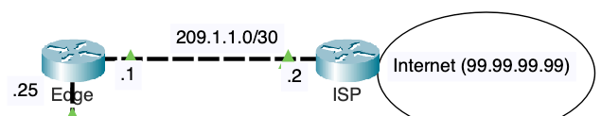

We will configure static routes on the Edge and ISP routers to ensure full network reachability between internal and external networks. The Edge router will be configured with a default static route, directing all traffic destined for networks outside the OSPF domain to the ISP router. Conversely, the ISP router will be configured with a static route pointing to the **10.0.0.0/8** network via the Edge router, enabling it to reach internal networks. This setup will bridge the OSPF-managed internal networks with external destinations, ensuring seamless communication across the entire network.

## Configuring a Static Route on ISP for 10.0.0.0/8

Configure a static route on ISP forwarding all traffic for 10.0.0.0/8 to the Edge router.



ISP(config)# **ip route 10.0.0.0 255.0.0.0 209.1.1.1**

ISP(config)# **end**

ISP# **show ip route**

Codes: L - local, C - connected, S - static, R - RIP, M - mobile, B - BGP

D - EIGRP, EX - EIGRP external, O - OSPF, IA - OSPF inter area

N1 - OSPF NSSA external type 1, N2 - OSPF NSSA external type 2

E1 - OSPF external type 1, E2 - OSPF external type 2, E - EGP

i - IS-IS, L1 - IS-IS level-1, L2 - IS-IS level-2, ia - IS-IS inter area

* - candidate default, U - per-user static route, o - ODR

P - periodic downloaded static route

Gateway of last resort is not set

S 10.0.0.0/8 [1/0] via 209.1.1.1

99.0.0.0/8 is variably subnetted, 2 subnets, 2 masks

C 99.99.99.0/24 is directly connected, Loopback0

L 99.99.99.99/32 is directly connected, Loopback0

209.1.1.0/24 is variably subnetted, 2 subnets, 2 masks

C 209.1.1.0/30 is directly connected, GigabitEthernet0/0/1

L 209.1.1.2/32 is directly connected, GigabitEthernet0/0/1

ISP#

The **ip route** command on the ISP router configures a static route, directing traffic for the **10.0.0.0/8** network through the next-hop IP address **209.1.1.1**. This command specifies that any traffic destined for the **10.0.0.0/8** network should be sent to **209.1.1.1**, which is the IP address of the interface on the Edge router connected to the ISP.

S 10.0.0.0/8 [1/0] via 209.1.1.1

Static route entry in the routing table

* **S 10.0.0.0/8 [1/0] via 209.1.1.1:** Indicates a static route (**S**) to the **10.0.0.0/8** network. The route has an administrative distance of 1 and a metric of 0, with the next-hop address being **209.1.1.1**.

This static route ensures that the ISP router can forward any traffic destined for the internal **10.0.0.0/8** network through the Edge router. This setup is crucial for allowing external traffic to reach the internal OSPF domain managed by the Edge router.

## Configuring a Default Static Route on Edge

Configure a default static route on ISP.



Edge(config)# **ip route 0.0.0.0 0.0.0.0 209.1.1.2**

Edge(config)# **end**

Edge# **show ip route static**

S* 0.0.0.0/0 [1/0] via 209.1.1.2

Edge#

The default static route on the Edge router with a **/0** prefix length is used to direct all traffic destined for networks not explicitly listed in the routing table to the next-hop address the ISP router. The use of a default static route on the Edge router ensures that any traffic destined for networks not specifically known to the Edge router will be forwarded to the ISP router. The **/0** prefix length (**0.0.0.0/0**) signifies the default route, which acts as a catch-all for any destination IP addresses that do not have a more specific match in the routing table.

## Propagating a Default Route within OSPF

As previously displayed the other routers in the OSPF routing domain such as MLS-1 do not have a default route. The only router with a default route is the Edge router.

By configuring **default-information originate**, the Edge router will inject a default route into the OSPF domain.

Edge(config)# **router ospf 1**

Edge(config-router)# **default-information originate**

The **default-information originate** command enables the Edge router to advertise a default route within the OSPF domain, ensuring that all OSPF routers have a path to reach external networks via the Edge router.

## Verifying the Default Route in Routing Tables



MLS-1# **show ip route ospf**

10.0.0.0/8 is variably subnetted, 11 subnets, 2 masks

O 10.2.2.0 [110/2] via 10.200.200.10, 00:40:07, GigabitEthernet1/0/3

O 10.3.3.0 [110/2] via 10.200.200.2, 00:40:07, GigabitEthernet1/0/1

O 10.4.4.0 [110/2] via 10.200.200.18, 00:40:07, GigabitEthernet1/0/6

O 10.200.200.4 [110/2] via 10.200.200.2, 00:40:07, GigabitEthernet1/0/1

[110/2] via 10.200.200.18, 00:40:07, GigabitEthernet1/0/6

O 10.200.200.12 [110/2] via 10.200.200.18, 00:40:07, GigabitEthernet1/0/6

[110/2] via 10.200.200.10, 00:40:07, GigabitEthernet1/0/3

O 10.200.200.20 [110/2] via 10.200.200.2, 00:40:07, GigabitEthernet1/0/1

[110/2] via 10.200.200.10, 00:40:07, GigabitEthernet1/0/3

O*E2 0.0.0.0/0 [110/1] via 10.200.200.25, 00:02:12, GigabitEthernet1/0/23

The **show ip route ospf** command on MLS-1 indicates that other internal OSPF routers now have a default route as a result of the **default-information originate** command configured on the Edge router. This default route (**O*E2 0.0.0.0/0**) directs traffic for any destination not explicitly known to the OSPF routers to the Edge router via the next-hop IP address **10.200.200.25** on interface **GigabitEthernet1/0/23**. This ensures that all internal OSPF routers can forward traffic to external networks through the Edge router, facilitating connectivity beyond the OSPF domain.

Here is another example, this time examining the output on MLS-4.



MLS-4# **show ip route ospf**

10.0.0.0/8 is variably subnetted, 11 subnets, 2 masks

O 10.1.1.0 [110/2] via 10.200.200.17, 00:50:43, GigabitEthernet1/0/6

O 10.2.2.0 [110/2] via 10.200.200.13, 00:50:33, GigabitEthernet1/0/4

O 10.3.3.0 [110/2] via 10.200.200.5, 00:50:43, GigabitEthernet1/0/2

O 10.200.200.0 [110/2] via 10.200.200.17, 00:50:43, GigabitEthernet1/0/6

[110/2] via 10.200.200.5, 00:50:43, GigabitEthernet1/0/2

O 10.200.200.8 [110/2] via 10.200.200.13, 00:50:33, GigabitEthernet1/0/4

[110/2] via 10.200.200.17, 00:50:33, GigabitEthernet1/0/6

O 10.200.200.20 [110/2] via 10.200.200.13, 00:50:33, GigabitEthernet1/0/4

[110/2] via 10.200.200.5, 00:50:33, GigabitEthernet1/0/2

O 10.200.200.24 [110/2] via 10.200.200.17, 00:50:43, GigabitEthernet1/0/6

O*E2 0.0.0.0/0 [110/1] via 10.200.200.17, 00:12:53, GigabitEthernet1/0/6

MLS-4#

The output from the **show ip route ospf** command on MLS-4 shows that all routers within the OSPF routing domain have received the default route (**O*E2 0.0.0.0/0**). This default route is propagated via OSPF and instructs routers to forward traffic destined for unknown networks to the next-hop router, which in this case is reachable via **10.200.200.17** on interface **GigabitEthernet1/0/6**. This ensures that all routers in the OSPF domain can route traffic to external networks efficiently, following the best path to the Edge router.

**Note**: The default route in the OSPF routing table shows a code of **O*E2**, which indicates that it is an external type 2 (E2) route. An E2 route has a metric of 1, the default for an external type 2 (E2) route. The cost of an E2 route is set by the originating router and does not increase as it propagates through the network. This metric of 1 reflects that the originating router (the Edge router) has configured the default route with a minimal cost to prioritize its selection for routing traffic destined for unknown external networks. Although all the routers will have a metric of 1, the routers will use the shortest path towards the Edge router. E2 routes are beyond the scope of this lab.

## Verify Reachability Outside the Internal OSPF Routing Domain

On MLS-4 use the ping 99.99.99.99 to verify reachability outside the internal OSPF routing domain. This will also verify that ISP has a route to the 10.0.0.0/8 network.

MLS-4# **ping 99.99.99.99**

Type escape sequence to abort.

Sending 5, 100-byte ICMP Echos to 99.99.99.99, timeout is 2 seconds:

.!!!!

Success rate is 80 percent (4/5), round-trip min/avg/max = 0/0/0 ms

MLS-4#

Notice that the first ping timed out. This was due to one or more ARP Requests along the way.

This can also be verified by performing a ping from any of the PCs in this network. This is an example of a ping from 10.4.4.40/24.

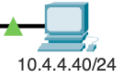

C:\> **ping 99.99.99.99**

Pinging 99.99.99.99 with 32 bytes of data:

Reply from 99.99.99.99: bytes=32 time<1ms TTL=252

Reply from 99.99.99.99: bytes=32 time<1ms TTL=252

Reply from 99.99.99.99: bytes=32 time<1ms TTL=252

Reply from 99.99.99.99: bytes=32 time<1ms TTL=252

Ping statistics for 99.99.99.99:

Packets: Sent = 4, Received = 4, Lost = 0 (0% loss),

Approximate round trip times in milli-seconds:

Minimum = 0ms, Maximum = 0ms, Average = 0ms

C:\>

# Creating a Discard Static Route



## Routing Loop between Edge and ISP

Packets destined for the **10.0.0.0/8** network, without a specific matching route in the routing table, will be forwarded from the Edge router to the ISP router and then back from the ISP to the Edge. This creates a routing loop where packets continuously bounce between the two routers until their TTL (Time-to-Live) value expires, indicating a lack of proper routing for that subnet.



MLS-4# **traceroute 10.111.111.111**

Type escape sequence to abort.

Tracing the route to 10.111.111.111

1 10.200.200.17 0 msec 0 msec 0 msec

2 10.200.200.25 0 msec 0 msec 0 msec

3 209.1.1.2 0 msec 0 msec 0 msec

4 10.200.200.25 0 msec 0 msec 0 msec

5 209.1.1.2 0 msec 0 msec 0 msec

6 10.200.200.25 0 msec 0 msec 0 msec

7 209.1.1.2 0 msec 0 msec 0 msec

8 10.200.200.25 0 msec 0 msec 0 msec

9 209.1.1.2 0 msec 0 msec 0 msec

10 10.200.200.25 0 msec 0 msec 0 msec

11 209.1.1.2 0 msec 0 msec 0 msec

12 10.200.200.25 0 msec 0 msec 0 msec

13 209.1.1.2 0 msec 0 msec 0 msec

14 10.200.200.25 0 msec 0 msec 0 msec

15 209.1.1.2 0 msec 0 msec 0 msec

16 10.200.200.25 0 msec 0 msec 0 msec

17 209.1.1.2 0 msec 0 msec 0 msec

18 10.200.200.25 0 msec 0 msec 0 msec

19 209.1.1.2 0 msec 0 msec 0 msec

20 10.200.200.25 0 msec 0 msec 0 msec

21 209.1.1.2 0 msec 0 msec 0 msec

22 10.200.200.25 0 msec 0 msec 0 msec

23 209.1.1.2 0 msec 0 msec 0 msec

24 10.200.200.25 0 msec 0 msec 0 msec

25 209.1.1.2 0 msec 0 msec 0 msec

26 10.200.200.25 0 msec 0 msec 0 msec

27 209.1.1.2 0 msec 0 msec 0 msec

28 10.200.200.25 0 msec 0 msec 0 msec

29 209.1.1.2 0 msec 0 msec 0 msec

30 10.200.200.25 0 msec 0 msec 0 msec

MLS-4#

The **traceroute** output indicates that packets destined for the **10.0.0.0/8** network, without a specific matching route, are being forwarded between the Edge and ISP routers repeatedly. The Edge router forwards these packets to the ISP router (via **209.1.1.2**), which then sends them back to the Edge router (via **10.200.200.25**). This looping continues until the Time-to-Live (TTL) value in the packets expires. This behavior suggests that there is no proper routing for the **10.0.0.0/8** network, causing packets to bounce back and forth between the two routers.

Note: The IPv4 addresses shown in a traceroute come from the exit interface the router uses to send the ICMP Time Exceeded message. This is why the ICMP message from Edge is 10.200.200.25 and not 209.1.1.1.

The **traceroute** command attempts to trace the path to a destination by sending packets with incrementally increasing TTL values. When the TTL reaches 30 hops without finding the destination, the **traceroute** command stops. In this case, the output shows packets bouncing between the Edge and ISP routers until the **traceroute** process halts after reaching the maximum limit of 30 hops.

A similar **tracert** command on PC with the IPv4 address 10.4.4.40/24 will provide similar output.



C:\> **tracert 10.111.111.111**

Tracing route to 10.111.111.111 over a maximum of 30 hops:

1 0 ms 0 ms 0 ms 10.4.4.1

2 0 ms 0 ms 0 ms 10.200.200.17

3 11 ms 0 ms 0 ms 10.200.200.25

4 0 ms 0 ms 0 ms 209.1.1.2

5 0 ms 0 ms 0 ms 10.200.200.25

6 0 ms 0 ms 0 ms 209.1.1.2

7 0 ms 0 ms 0 ms 10.200.200.25

8 0 ms 0 ms 0 ms 209.1.1.2

9 0 ms 0 ms 0 ms 10.200.200.25

10 0 ms 0 ms 0 ms 209.1.1.2

11 0 ms 0 ms 0 ms 10.200.200.25

<output omitted>

28 0 ms 0 ms 0 ms 209.1.1.2

29 0 ms 0 ms 0 ms 10.200.200.25

30 0 ms 0 ms 0 ms 209.1.1.2

Trace complete.

C:\>

## Configuring a Discard Static Route on Edge

A discard static route directs traffic for a specific network to the null interface (**null0**), effectively dropping packets destined for that network. Its purpose is to prevent routing loops and efficiently handle packets that do not have a more specific route, ensuring they are discarded rather than forwarded until the TTL expires.

The discard static route ensures that packets to unknown subnets within the **10.0.0.0/8** range are efficiently discarded, conserving network resources and maintaining stability. By using the **null0** interface, the Edge router is configured to drop any traffic to the **10.0.0.0/8** network that cannot be routed more specifically, effectively preventing potential routing issues.



Edge(config)# **ip route 10.0.0.0 255.0.0.0 null0**

Edge(config)# **end**

Edge# **show ip route**

Codes: L - local, C - connected, S - static, R - RIP, M - mobile, B - BGP

D - EIGRP, EX - EIGRP external, O - OSPF, IA - OSPF inter area

N1 - OSPF NSSA external type 1, N2 - OSPF NSSA external type 2

E1 - OSPF external type 1, E2 - OSPF external type 2, E - EGP

i - IS-IS, L1 - IS-IS level-1, L2 - IS-IS level-2, ia - IS-IS inter area

* - candidate default, U - per-user static route, o - ODR

P - periodic downloaded static route

Gateway of last resort is 209.1.1.2 to network 0.0.0.0

10.0.0.0/8 is variably subnetted, 13 subnets, 4 masks

S 10.0.0.0/8 is directly connected, Null0

O 10.1.1.0/24 [110/2] via 10.200.200.26, 01:23:04, GigabitEthernet0/0/0

O 10.2.2.0/24 [110/3] via 10.200.200.26, 01:23:04, GigabitEthernet0/0/0

O 10.3.3.0/24 [110/3] via 10.200.200.26, 01:22:54, GigabitEthernet0/0/0

O 10.4.4.0/24 [110/3] via 10.200.200.26, 01:23:04, GigabitEthernet0/0/0

O 10.200.200.0/30 [110/2] via 10.200.200.26, 01:22:54, GigabitEthernet0/0/0

O 10.200.200.4/30 [110/3] via 10.200.200.26, 01:23:04, GigabitEthernet0/0/0

O 10.200.200.8/30 [110/2] via 10.200.200.26, 01:23:04, GigabitEthernet0/0/0

O 10.200.200.12/30 [110/3] via 10.200.200.26, 01:23:04, GigabitEthernet0/0/0

O 10.200.200.16/30 [110/2] via 10.200.200.26, 01:23:04, GigabitEthernet0/0/0

O 10.200.200.20/30 [110/3] via 10.200.200.26, 01:23:04, GigabitEthernet0/0/0

C 10.200.200.24/30 is directly connected, GigabitEthernet0/0/0

L 10.200.200.25/32 is directly connected, GigabitEthernet0/0/0

209.1.1.0/24 is variably subnetted, 2 subnets, 2 masks

C 209.1.1.0/30 is directly connected, GigabitEthernet0/0/1

L 209.1.1.1/32 is directly connected, GigabitEthernet0/0/1

S* 0.0.0.0/0 [1/0] via 209.1.1.2

Edge#

By configuring a discard static route to **null0** (**ip route 10.0.0.0 255.0.0.0 null0**),any packets destined for the **10.0.0.0/8** network that do not match a more specific route, an active 10.0.0.0 subnet, will be discarded. This prevents the packets from being forwarded in a loop between the Edge and ISP routers. If no specific routes are found for the **10.0.0.0/8** network, the router will drop these packets rather than sending them to the next hop, which could cause a routing loop.



MLS-4# **traceroute 10.111.111.111**

Type escape sequence to abort.

Tracing the route to 10.111.111.111

1 10.200.200.17 0 msec 0 msec 0 msec

2 10.200.200.25 0 msec 0 msec 0 msec

3 10.200.200.25 !H !H *

MLS-4#

When a packet with the destination IP address **10.111.111.111** arrives at the Edge router, the router checks its routing table for the most specific match. The packet does not match any specific routes for the **10.0.0.0** network, such as **10.200.200.0/30**, but it does match the discard static route **10.0.0.0/8**, which directs it to the **null0** interface. The **null0** interface is used to discard packets, so the packet is dropped and not forwarded further. This prevents the packet from being forwarded to the ISP using the default route (**0.0.0.0/0**), as the discard route takes precedence. This setup efficiently handles packets destined for the **10.0.0.0/8** network without specific matches, conserving network resources and preventing routing loops.

## Verifying the Discard Route

With the discard static route in place, packets destined for **10.111.111.111** will now be dropped by the Edge router as shown by the traceroute from the same 10.4.4.40/24 PC.



C:\> **tracert 10.111.111.111**

Tracing route to 10.111.111.111 over a maximum of 30 hops:

1 0 ms 0 ms 0 ms 10.4.4.1

2 0 ms 0 ms 0 ms 10.200.200.17

3 0 ms 0 ms 0 ms 10.200.200.25

4 0 ms 0 ms 0 ms 10.200.200.25

5 0 ms 0 ms 0 ms 10.200.200.25

6 0 ms 0 ms 7 ms 10.200.200.25

<output omitted>

25 0 ms 0 ms 0 ms 10.200.200.25

26 0 ms 0 ms 0 ms 10.200.200.25

27 0 ms 0 ms 0 ms 10.200.200.25

28 0 ms 0 ms 0 ms 10.200.200.25

29 0 ms 0 ms 0 ms 10.200.200.25

30 0 ms 0 ms 0 ms 10.200.200.25

Trace complete.

C:\>

The **tracert** command demonstrates this by showing packets being sent with a TTL from 1 to 30, but all packets are being dropped by the Edge router. As a result, the trace shows repeated hops to **10.200.200.25** without progressing further, indicating that the packets are consistently discarded by the Edge router and not forwarded to the ISP.

Devices within the OSPF routing domain can still have their packets forwarded outside the internal network via the default route on all the OSPF routers including Edge. From the same PC, verify that we still have reachability outside the OSPF routing domain by pinging 99.99.99.99.

C:\> **ping 99.99.99.99**

Pinging 99.99.99.99 with 32 bytes of data:

Reply from 99.99.99.99: bytes=32 time<1ms TTL=252

Reply from 99.99.99.99: bytes=32 time<1ms TTL=252

Reply from 99.99.99.99: bytes=32 time<1ms TTL=252

Reply from 99.99.99.99: bytes=32 time<1ms TTL=252

Ping statistics for 99.99.99.99:

Packets: Sent = 4, Received = 4, Lost = 0 (0% loss),

Approximate round trip times in milli-seconds:

Minimum = 0ms, Maximum = 0ms, Average = 0ms

C:\>

# Modifying the Auto-Cost Reference Bandwidth



SPF determines the cost of a route based on the bandwidth of the outgoing interface. Cisco IOS calculates the OSPF cost using the formula:

Cost = Reference Bandwidth/Interface Bandwidth

**Default Auto-Cost Reference Bandwidth**

* **Reference Bandwidth:** By default, Cisco IOS sets the reference bandwidth to 100 Mbps (100,000,000 bits per second).
* **Default Cost Calculation:** The default OSPF cost for an interface is calculated by dividing the reference bandwidth (100 Mbps) by the interface bandwidth. For example:
  + A 100 Mbps Fast Ethernet interface will have a cost of 1 (100,000,000 / 100,000,000).
  + A 10 Mbps Ethernet interface will have a cost of 10 (100,000,000 / 10,000,000).
  + A 1 Gbps Gigabit Ethernet interface will have a cost of 1 (100,000,000 / 1,000,000,000, rounded up to 1).

**Issues with High-Speed Links**

* **Greater Than 100 Mbps:** The default reference bandwidth of 100 Mbps becomes problematic for interfaces with bandwidth greater than 100 Mbps. Both Fast Ethernet (100 Mbps) and higher-speed links like Gigabit Ethernet (1 Gbps) and 10 Gigabit Ethernet (10 Gbps) will all default to the same cost of 1, which does not accurately represent the difference in speeds.
* **Cost Discrepancy:** This can lead to suboptimal routing decisions, as OSPF will view a 100 Mbps link, a 1 Gbps link, and a 10 Gbps link as having the same cost, even though the 10 Gbps link is significantly faster.

**Adjusting Auto-Cost Reference Bandwidth**

To properly account for higher-speed links, you can adjust the auto-cost reference bandwidth to a higher value, such as 10 Gbps (10,000 Mbps). This allows OSPF to differentiate between different high-speed interfaces more accurately.



Edge(config)# **router ospf 1**

Edge(config-router)# **auto-cost reference-bandwidth 10000**

% OSPF: Reference bandwidth is changed.

Please ensure reference bandwidth is consistent across all routers.

Edge(config-router)#

This command sets the reference bandwidth to 10 Gbps (10,000 Mbps), making the cost calculations more appropriate for high-speed links. For example, with a reference bandwidth of 10 Gbps:

* A 100 Mbps Fast Ethernet interface will have a cost of 100 (10,000,000,000 / 100,000,000).
* A 1 Gbps Gigabit Ethernet interface will have a cost of 10 (10,000,000,000 / 1,000,000,000).
* A 10 Gbps interface will have a cost of 1 (10,000,000,000 / 10,000,000,000).

When adjusting the auto-cost reference bandwidth, it is crucial to ensure that the reference bandwidth setting is consistent across all OSPF routers in the network. This consistency is necessary to maintain accurate and uniform cost calculations for routing decisions across the entire OSPF domain, preventing routing inefficiencies and discrepancies.



MLS-1(config)# **router ospf 1**

MLS-1(config-router)# **auto-cost reference-bandwidth 10000**

% OSPF: Reference bandwidth is changed.

Please ensure reference bandwidth is consistent across all routers.

MLS-1(config-router)#



MLS-2(config)# **router ospf 1**

MLS-2(config-router)# **auto-cost reference-bandwidth 10000**

% OSPF: Reference bandwidth is changed.

Please ensure reference bandwidth is consistent across all routers.

MLS-2(config-router)#



MLS-3(config)# **router ospf 1**

MLS-3(config-router)# **auto-cost reference-bandwidth 10000**

% OSPF: Reference bandwidth is changed.

Please ensure reference bandwidth is consistent across all routers.

MLS-3(config-router)#



MLS-4(config)# **router ospf 1**

MLS-4(config-router)# **auto-cost reference-bandwidth 10000**

% OSPF: Reference bandwidth is changed.

Please ensure reference bandwidth is consistent across all routers.

MLS-4(config-router)#

OSPF uses the interface bandwidth to calculate the cost metric, with the default reference bandwidth set to 100 Mbps. This default can be insufficient for modern high-speed networks, leading to inaccurate cost metrics. Adjusting the auto-cost reference bandwidth to a higher value, such as 10 Gbps, allows OSPF to better differentiate between various link speeds, ensuring more efficient and accurate routing decisions.

Here is the routing table on MLS-4 BEFORE the modifying the reference bandwidth.



MLS-4# **show ip route ospf**

10.0.0.0/8 is variably subnetted, 11 subnets, 2 masks

O 10.1.1.0 [110/2] via 10.200.200.17, 00:50:43, GigabitEthernet1/0/6

O 10.2.2.0 [110/2] via 10.200.200.13, 00:50:33, GigabitEthernet1/0/4

O 10.3.3.0 [110/2] via 10.200.200.5, 00:50:43, GigabitEthernet1/0/2

O 10.200.200.0 [110/2] via 10.200.200.17, 00:50:43, GigabitEthernet1/0/6

[110/2] via 10.200.200.5, 00:50:43, GigabitEthernet1/0/2

O 10.200.200.8 [110/2] via 10.200.200.13, 00:50:33, GigabitEthernet1/0/4

[110/2] via 10.200.200.17, 00:50:33, GigabitEthernet1/0/6

O 10.200.200.20 [110/2] via 10.200.200.13, 00:50:33, GigabitEthernet1/0/4

[110/2] via 10.200.200.5, 00:50:33, GigabitEthernet1/0/2

O 10.200.200.24 [110/2] via 10.200.200.17, 00:50:43, GigabitEthernet1/0/6

O*E2 0.0.0.0/0 [110/1] via 10.200.200.17, 00:12:53, GigabitEthernet1/0/6

Here is the routing table on MLS-4 AFTER the modifying the reference bandwidth.

MLS-4# **show ip route ospf**

10.0.0.0/8 is variably subnetted, 11 subnets, 2 masks

O 10.1.1.0 [110/20] via 10.200.200.17, 00:02:19, GigabitEthernet1/0/6

O 10.2.2.0 [110/20] via 10.200.200.13, 00:02:19, GigabitEthernet1/0/4

O 10.3.3.0 [110/20] via 10.200.200.5, 00:01:52, GigabitEthernet1/0/2

O 10.200.200.0 [110/20] via 10.200.200.17, 00:02:02, GigabitEthernet1/0/6

[110/20] via 10.200.200.5, 00:02:02, GigabitEthernet1/0/2

O 10.200.200.8 [110/20] via 10.200.200.13, 00:02:19, GigabitEthernet1/0/4

[110/20] via 10.200.200.17, 00:02:19, GigabitEthernet1/0/6

O 10.200.200.20 [110/20] via 10.200.200.13, 00:02:02, GigabitEthernet1/0/4

[110/20] via 10.200.200.5, 00:02:02, GigabitEthernet1/0/2

O 10.200.200.24 [110/20] via 10.200.200.17, 00:02:19, GigabitEthernet1/0/6

O*E2 0.0.0.0/0 [110/1] via 10.200.200.17, 02:17:01, GigabitEthernet1/0/6

After modifying the OSPF reference bandwidth to 10,000 Mbps on MLS-4, the OSPF cost metric for routes using Gigabit Ethernet interfaces increased from 2 to 20, effectively multiplying the previous metric by 10, due to the higher reference bandwidth now accurately reflecting the relative capacity of these faster links.

# Modifying the Hello and Dead Intervals

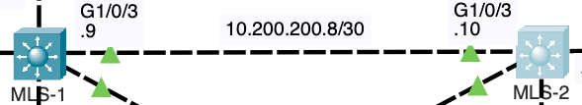

## Hello and Dead Intervals

OSPF uses hello packets and the dead interval to establish and maintain neighbor adjacencies. In the output for **show ip ospf interface g 1/0/3** on MLS-1, we see that OSPF is running on the **GigabitEthernet1/0/3** interface.

**Hello Interval:** The router sends hello packets every 10 seconds to its OSPF neighbors. These hello packets are used to maintain communication and confirm that the neighbors are still reachable.

**Dead Interval:** This is set to 40 seconds, which means if the router does not receive hello packets from a neighbor within 40 seconds, it will consider that neighbor as down and will remove the neighbor from its OSPF neighbor list.

OSPF Hello packets are essential in creating and maintaining neighbor adjacencies between routers sharing a link on the same IP network. The hello packets help in forming and maintaining neighbor relationships by periodically confirming the presence of neighboring OSPF routers.

The **dead Interval** provides a timeout period. If no hello packets are received from a neighbor within this time frame, the OSPF router assumes the neighbor is unreachable and terminates the adjacency.



MLS-1# **show ip ospf interface g 1/0/3**

GigabitEthernet1/0/3 is up, line protocol is up

Internet address is 10.200.200.9/30, Area 0

Process ID 1, Router ID 1.1.1.1, Network Type BROADCAST, Cost: 1

Transmit Delay is 1 sec, State BDR, Priority 1

Designated Router (ID) 2.2.2.2, Interface address 10.200.200.10

Backup Designated Router (ID) 1.1.1.1, Interface address 10.200.200.9

Timer intervals configured, Hello 10, Dead 40, Wait 40, Retransmit 5

Hello due in 00:00:01

Index 5/5, flood queue length 0

Next 0x0(0)/0x0(0)

Last flood scan length is 1, maximum is 1

Last flood scan time is 0 msec, maximum is 0 msec

Neighbor Count is 1, Adjacent neighbor count is 1

Adjacent with neighbor 2.2.2.2 (Designated Router)

Suppress hello for 0 neighbor(s)

MLS-1#

In this example, the **GigabitEthernet1/0/3** interface has an internet address of **10.200.200.9/30** and operates in Area 0 with a hello interval of 10 seconds and a dead interval of 40 seconds. The hello packets are sent every 10 seconds, and if no hello packets are received from the neighbor **2.2.2.2** within 40 seconds, the adjacency will be considered lost.

## Creating a Mismatch of Hello and Dead Intervals on MLS-1

OSPF requires the Hello and Dead intervals to match between two routers to form and maintain a neighbor adjacency. Change the OSPF hello and dead intervals on the interface **GigabitEthernet1/0/3** of router MLS-1.



MLS-1(config)# **interface g 1/0/3**

MLS-1(config-if)# **ip ospf hello-interval 5**

MLS-1(config-if)# **ip ospf dead-interval 20**

MLS-1(config-if)#

03:12:31: %OSPF-5-ADJCHG: Process 1, Nbr 2.2.2.2 on GigabitEthernet1/0/3 from FULL to DOWN, Neighbor Down: Dead timer expired

03:12:31: %OSPF-5-ADJCHG: Process 1, Nbr 2.2.2.2 on GigabitEthernet1/0/3 from FULL to DOWN, Neighbor Down: Interface down or detached

MLS-1(config-if)#

**Explanation of Commands:**

* **ip ospf hello-interval 5**: This command sets the interval at which the router sends OSPF hello packets on the **GigabitEthernet1/0/3** interface to every 5 seconds. OSPF hello packets are used to discover and maintain adjacency with other OSPF routers.
* **ip ospf dead-interval 20**: This command sets the dead interval to 20 seconds on the same interface. The dead interval is the time that an OSPF router waits without receiving a hello packet before declaring the OSPF neighbor as down.

**Explanation of Output:**

* **%OSPF-5-ADJCHG: Process 1, Nbr 2.2.2.2 on GigabitEthernet1/0/3 from FULL to DOWN, Neighbor Down: Dead timer expired**: This log message indicates that the OSPF adjacency with neighbor 2.2.2.2 has transitioned from a fully established state to down because the dead timer expired. This likely occurred because the neighbor did not send a hello packet within the newly configured dead interval of 20 seconds.
* **%OSPF-5-ADJCHG: Process 1, Nbr 2.2.2.2 on GigabitEthernet1/0/3 from FULL to DOWN, Neighbor Down: Interface down or detached**: This message can indicate a physical or logical disconnect on the interface, but given the context with the dead timer expiration, it more likely refers to the loss of neighbor adjacency due to the failure to meet the hello and dead interval conditions post configuration change.

Changing the OSPF hello and dead intervals can have immediate effects on OSPF neighbor relationships, especially if the new intervals are not consistent with neighboring routers. If the neighboring router's intervals do not match or if it cannot adhere to the shorter interval timing, the adjacency will be lost, leading to network topology changes and potential routing disruptions. It's crucial to ensure that all routers in an OSPF area have matching hello and dead intervals to maintain stable adjacencies.

The output on MLS-2 also indicates that the adjacency has been lost.



MLS-2#

%SYS-5-CONFIG_I: Configured from console by console

MLS-2#

03:12:33: %OSPF-5-ADJCHG: Process 1, Nbr 1.1.1.1 on GigabitEthernet1/0/3 from FULL to DOWN, Neighbor Down: Dead timer expired

03:12:33: %OSPF-5-ADJCHG: Process 1, Nbr 1.1.1.1 on GigabitEthernet1/0/3 from FULL to DOWN, Neighbor Down: Interface down or detached

MLS-2#

The lost adjacency can further be verified by using the **show ip ospf neighbor** command on either MLS-1 or MLS-2.



MLS-1# **show ip ospf neighbor**

Neighbor ID Pri State Dead Time Address Interface

3.3.3.3 1 FULL/DR 00:00:33 10.200.200.2 GigabitEthernet1/0/1

4.4.4.4 1 FULL/DR 00:00:38 10.200.200.18 GigabitEthernet1/0/6

10.10.10.10 1 FULL/DR 00:00:32 10.200.200.25 GigabitEthernet1/0/23

MLS-1#

The command **show ip ospf neighbor** on MLS-1 displays the OSPF neighbors that the router currently recognizes and maintains an adjacency with. In your example, the output lists neighbors with IDs **3.3.3.3**, **4.4.4.4**, and **10.10.10.10**, each in a **FULL/DR** state, indicating fully established adjacencies with these routers as designated routers on their respective interfaces.

* If a specific neighbor, such as **2.2.2.2**, does not appear in this list, it means that MLS-1 does not currently have an OSPF adjacency with that neighbor. In the case of 2.2.2.2 it was due to mismatched OSPF hello and dead intervals. The adjacency dropped due to the dead timer expiring.

Changing the OSPF hello and dead timers on MLS-2 to match those of MLS-1 effectively reestablishes the OSPF adjacency between the two routers. By configuring the **hello-interval** to 5 seconds and the **dead-interval** to 20 seconds on MLS-2, both routers now share consistent timing for sending and expecting OSPF hello packets.



MLS-2(config)# **interface gig 1/0/3**

MLS-2(config-if)# **ip ospf hello-interval 5**

MLS-2(config-if)# **ip ospf dead-interval 20**

03:25:19: %OSPF-5-ADJCHG: Process 1, Nbr 1.1.1.1 on GigabitEthernet1/0/3 from LOADING to FULL, Loading Done

MLS-2(config-if)#

This synchronization ensures that both routers are able to maintain regular communication and verify each other's presence within the specified intervals, preventing the dead timer from expiring prematurely. The log message from MLS-2, indicating a transition from the LOADING state to FULL, confirms that the OSPF process successfully synchronized the link-state database with MLS-1, completing the adjacency establishment. This alignment of intervals is crucial for maintaining stable and reliable OSPF neighbor relationships.

The Hello and Dead intervals are verified by using the **show ip ospf interface** command on MLS-2.

MLS-2# **show ip ospf interface g 1/0/3**

GigabitEthernet1/0/3 is up, line protocol is up

Internet address is 10.200.200.10/30, Area 0

Process ID 1, Router ID 2.2.2.2, Network Type BROADCAST, Cost: 10

Transmit Delay is 1 sec, State DR, Priority 1

Designated Router (ID) 2.2.2.2, Interface address 10.200.200.10

Backup Designated Router (ID) 1.1.1.1, Interface address 10.200.200.9

Timer intervals configured, Hello 5, Dead 20, Wait 20, Retransmit 5

Hello due in 00:00:01

Index 4/4, flood queue length 0

Next 0x0(0)/0x0(0)

Last flood scan length is 1, maximum is 1

Last flood scan time is 0 msec, maximum is 0 msec

Neighbor Count is 1, Adjacent neighbor count is 1

Adjacent with neighbor 1.1.1.1 (Backup Designated Router)

Suppress hello for 0 neighbor(s)

MLS-2#

The neighbor adjacency with 1.1.1.1 (MLS-1) is verified on MLS-2 using the **show ip ospf neighbor** command.

MLS-2# **show ip ospf neighbor**

Neighbor ID Pri State Dead Time Address Interface

1.1.1.1 1 FULL/BDR 00:00:15 10.200.200.9 GigabitEthernet1/0/3

4.4.4.4 1 FULL/DR 00:00:30 10.200.200.14 GigabitEthernet1/0/4

3.3.3.3 1 FULL/DR 00:00:35 10.200.200.21 GigabitEthernet1/0/5

MLS-2#

On MLS-1, the Hello and Dead intervals are verified by using the **show ip ospf interface** command.



03:25:19: %OSPF-5-ADJCHG: Process 1, Nbr 2.2.2.2 on GigabitEthernet1/0/3 from LOADING to FULL, Loading Done

MLS-1# **show ip ospf interface g 1/0/3**

GigabitEthernet1/0/3 is up, line protocol is up

Internet address is 10.200.200.9/30, Area 0

Process ID 1, Router ID 1.1.1.1, Network Type BROADCAST, Cost: 10

Transmit Delay is 1 sec, State BDR, Priority 1

Designated Router (ID) 2.2.2.2, Interface address 10.200.200.10

Backup Designated Router (ID) 1.1.1.1, Interface address 10.200.200.9

Timer intervals configured, Hello 5, Dead 20, Wait 20, Retransmit 5

Hello due in 00:00:03

Index 5/5, flood queue length 0

Next 0x0(0)/0x0(0)

Last flood scan length is 1, maximum is 1

Last flood scan time is 0 msec, maximum is 0 msec

Neighbor Count is 1, Adjacent neighbor count is 1

Adjacent with neighbor 2.2.2.2 (Designated Router)

Suppress hello for 0 neighbor(s)

MLS-1#

Also, on MLS-1, the neighbor adjacency with 2.2.2.2 (MLS-2) is verified using the **show ip ospf neighbor** command.

MLS-1# **show ip ospf neighbor**

Neighbor ID Pri State Dead Time Address Interface

3.3.3.3 1 FULL/DR 00:00:31 10.200.200.2 GigabitEthernet1/0/1

2.2.2.2 1 FULL/DR 00:00:15 10.200.200.10 GigabitEthernet1/0/3

4.4.4.4 1 FULL/DR 00:00:30 10.200.200.18 GigabitEthernet1/0/6

10.10.10.10 1 FULL/DR 00:00:30 10.200.200.25 GigabitEthernet1/0/23

MLS-1#

## Effect on Network when Neighbor Adjacency is Lost

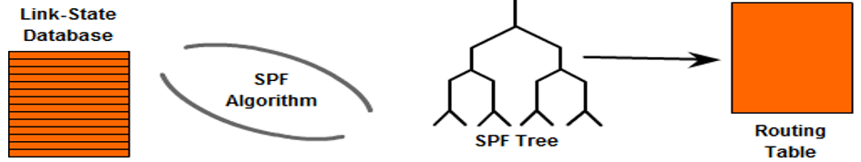

When a neighbor adjacency is lost in OSPF, several events occur to ensure network stability and to inform other routers of the topology change:

1. **Removal from Neighbor List:** The OSPF router removes the lost neighbor from its neighbor list. This action indicates that the router no longer considers the lost neighbor as an active OSPF peer. This includes removal from the LSDB (Link-State Database). The OSPF routers synchronize their LSDBs by exchanging LSAs. When an adjacency is lost, the router sends an LSA update indicating the change in topology.
2. **Link-State Update (LSU):** The router generates and floods a new Link-State Advertisement (LSA) to inform all other OSPF routers in the area of the topology change. This LSA reflects the removal of the routes that were previously reachable through the lost neighbor.
3. **SPF Calculation:** Upon receiving the updated LSAs, all OSPF routers in the area recalculate their shortest path first (SPF) tree to find the new best paths through the network. This recalculation ensures that all routers have a consistent and up-to-date view of the network topology.
4. **Routing Table Route Removal:** Routes that were learned via the lost neighbor are removed from the OSPF router's routing table. This action prevents traffic from being sent to an unreachable destination.
5. **Convergence:** The network converges to a new stable state where all routers have a consistent understanding of the network topology without the lost neighbor.

**Our Scenario**

Using the previous example, if MLS-1 loses adjacency with the neighbor **2.2.2.2** on **GigabitEthernet1/0/3**:

1. MLS-1 stops receiving hello packets from **2.2.2.2** within the dead interval (40 seconds).
2. MLS-1 removes **2.2.2.2** from its neighbor list and generates an LSA to notify other OSPF routers of the change.
3. Other OSPF routers receive the LSA and update their own LSAs.
4. All OSPF routers recalculate their SPF tree and update their routing tables.
5. Routes that were reachable through **2.2.2.2** are removed, and the network converges to a new stable state without the lost neighbor.

This process helps maintain accurate routing information and ensures that the network can quickly adapt to changes, such as the loss of a neighbor.

# Configuring Inter-Router Links as Point-to-Point

## Multicasts over Ethernet

In OSPF, multicast addresses 224.0.0.5 and 224.0.0.6, with corresponding Ethernet MAC addresses 01:00:5E:00:00:05 and 01:00:5E:00:00:06, are used to efficiently send routing updates and hello packets to multiple routers on the same network segment.

When an OSPF router sends a packet to these multicast addresses, it is encapsulated with the corresponding MAC address at Layer 2. Ethernet switches, upon receiving these multicast frames, treat them similarly to broadcast frames and forward them out all ports in the same VLAN (except the port they were received on). This ensures that all OSPF routers on the segment receive the packets, allowing for efficient distribution of routing information and updates.

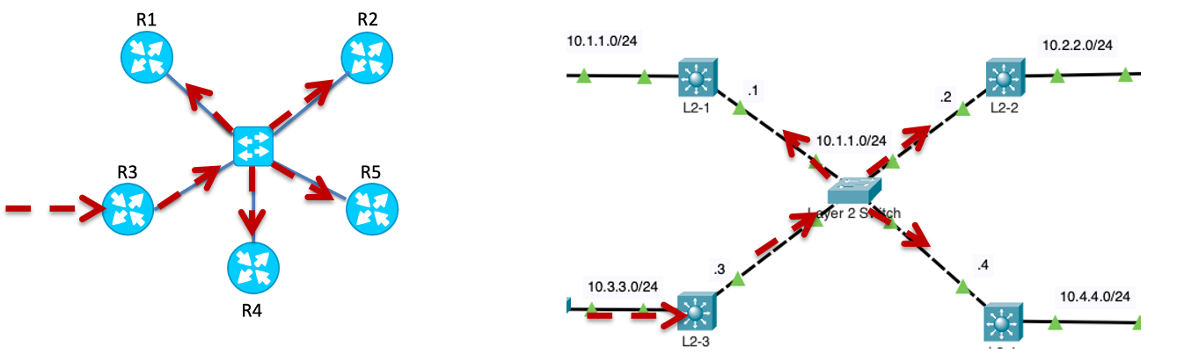

The use of multicast addresses in OSPF for sending LSAs (Link-State Advertisements) can lead to excessive flooding, especially in large broadcast networks. Since Ethernet switches treat these multicast frames similarly to broadcast frames, they forward them out all ports in the same VLAN, which can result in significant network overhead and congestion. This widespread dissemination of LSAs can overwhelm network devices, degrade performance, and increase the likelihood of packet collisions and delays, particularly in dense network environments with numerous OSPF routers.

## The Role of the Designated Router (DR) and Backup Designated Router (BDR)

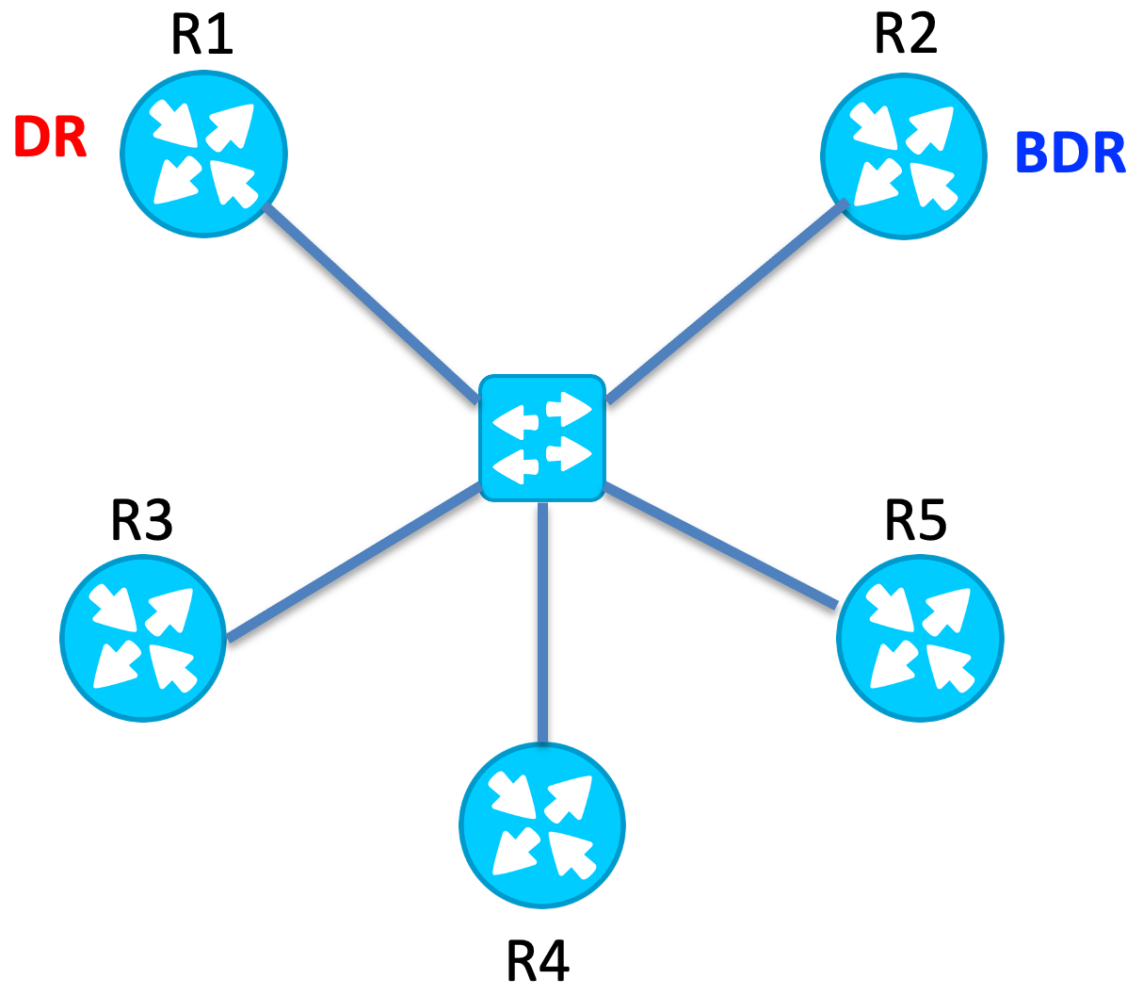 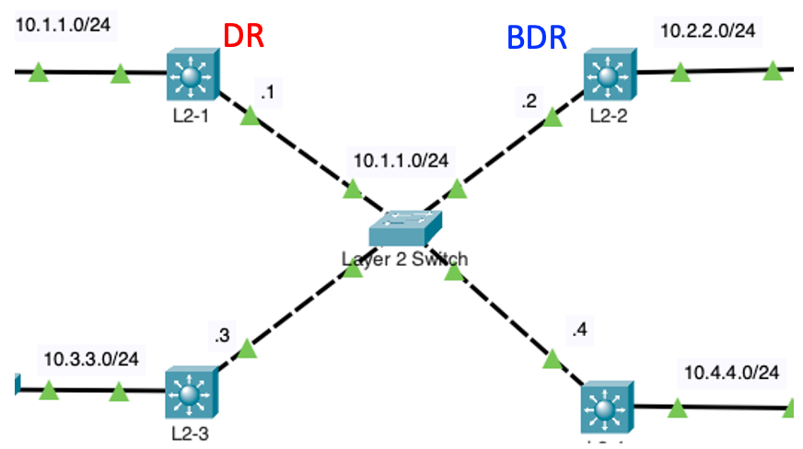

In OSPF networks, the Designated Router (DR) and Backup Designated Router (BDR) play critical roles in reducing the overhead of link-state routing. The DR is responsible for managing the link-state advertisements (LSAs) among routers within a broadcast or multi-access network, such as Ethernet. This role centralizes LSA management and minimizes the number of adjacencies each router must maintain, effectively reducing the amount of OSPF traffic and the use of router resources. The DR sends and receives LSAs to and from other routers, ensuring that all nodes in the area have a consistent view of the network topology. The BDR is in place to provide redundancy; it monitors the DR and takes over its duties if the DR fails, maintaining network stability and preventing interruptions in the OSPF process. This arrangement ensures efficient communication and stability within OSPF networks, preventing each router from having to form full adjacencies with every other router, which would be significantly resource-intensive on larger networks.



In our network topology, although the connections appear to involve Ethernet (broadcast) segments, each link between the routers (MLS-1, MLS-2, MLS-3, MLS-4, Edge, and ISP) can be configured as inter-router point-to-point links. This setup is suitable because each link directly connects only two routers, which simplifies the OSPF configuration by eliminating the need for Designated Router (DR) and Backup Designated Router (BDR) elections.

## Examining the Network Type

The **show ip ospf interface** command displays the network type as BROADCAST (Ethernet) and the state of this router (DR, BDR or DROTHER), along with the router IDs of the routers that are the DR and BDR if not this router. The network type must be the same between two routers to form an adjacency.



Edge# **show ip ospf interface g 0/0/0**

GigabitEthernet0/0/0 is up, line protocol is up

Internet address is 10.200.200.25/30, Area 0

Process ID 1, Router ID 10.10.10.10, Network Type BROADCAST, Cost: 10

Transmit Delay is 1 sec, State DR, Priority 1

Designated Router (ID) 10.10.10.10, Interface address 10.200.200.25

Backup Designated Router (ID) 1.1.1.1, Interface address 10.200.200.26

Timer intervals configured, Hello 10, Dead 40, Wait 40, Retransmit 5

Hello due in 00:00:07

Index 1/1, flood queue length 0

Next 0x0(0)/0x0(0)

Last flood scan length is 1, maximum is 1

Last flood scan time is 0 msec, maximum is 0 msec

Neighbor Count is 1, Adjacent neighbor count is 1

Adjacent with neighbor 1.1.1.1 (Backup Designated Router)

Suppress hello for 0 neighbor(s)

Edge#

The command **show ip ospf neighbor** provides information about OSPF adjacencies, indicating the state of each neighbor relationship and showing whether the neighbor is a Designated Router (DR) or Backup Designated Router (BDR). The output shows that there is a DR for each adjacency, with the "State" column listing "FULL/DR" for each neighbor, meaning these neighbors are the DRs on their respective links. The specific neighbor acting as the DR for each adjacency is identified by their Neighbor ID and associated IP address on the given interface.



MLS-1# **show ip ospf neighbor**

Neighbor ID Pri State Dead Time Address Interface

3.3.3.3 1 FULL/DR 00:00:31 10.200.200.2 GigabitEthernet1/0/1

2.2.2.2 1 FULL/DR 00:00:15 10.200.200.10 GigabitEthernet1/0/3

4.4.4.4 1 FULL/DR 00:00:30 10.200.200.18 GigabitEthernet1/0/6

10.10.10.10 1 FULL/DR 00:00:30 10.200.200.25 GigabitEthernet1/0/23

MLS-1#

On inter-router point-to-point links, the roles of DR and BDR are not necessary due to the nature of the connection, which involves only two routers. In these scenarios, each router needs to form an OSPF adjacency only with the other router on the link, simplifying the OSPF process. The presence of a DR and BDR is primarily beneficial in broadcast and multi-access networks where multiple routers are connected on the same network segment, as these roles help manage and reduce the overhead of OSPF routing updates among many routers.

Configuring these links as point-to-point in OSPF is advantageous, as it reduces the OSPF overhead, simplifies the neighbor adjacency process, and speeds up the convergence time, making it ideal for direct, router-to-router connections within this topology.

## Modifying the Network Type as point-to-point

To explicitly configure an OSPF interface as a point-to-point connection, you can use the **ip ospf network point-to-point** command in the interface configuration mode.



Edge(config)# **interface gig 0/0/0**

Edge(config-if)# **ip ospf network point-to-point**

Edge(config-if)# **exit**

This command changes the OSPF network type of the interface to point-to-point, which effectively eliminates the need for a DR and BDR on that link. The result is that OSPF on these interfaces treats the connection as a direct link between two routers, simplifying the OSPF protocol operations by immediately forming a full adjacency without the election process. This configuration optimizes OSPF behavior for point-to-point links by reducing protocol complexity and accelerating convergence, making it ideal for direct router-to-router connections often found in WAN links and serial connections.

Repeat these same commands for all the inter-router links on all OSPF routers

MLS-1



MLS-1(config)# **interface gig 1/0/1**

MLS-1(config-if)# **ip ospf network point-to-point**

MLS-1(config-if)# **exit**

MLS-1(config)# **interface gig 1/0/3**

MLS-1(config-if)# **ip ospf network point-to-point**

MLS-1(config-if)# **exit**

MLS-1(config)# **interface gig 1/0/6**

MLS-1(config-if)# **ip ospf network point-to-point**

MLS-1(config-if)# **exit**

MLS-1(config)# **interface gig 1/0/23**

MLS-1(config-if)# **ip ospf network point-to-point**

MLS-1(config-if)# **exit**

MLS-2



MLS-2(config)# **interface gig 1/0/3**

MLS-2(config-if)# **ip ospf network point-to-point**

MLS-2(config-if)# **exit**

MLS-2(config)# **interface gig 1/0/4**

MLS-2(config-if)# **ip ospf network point-to-point**

MLS-2(config-if)# **exit**

MLS-2(config)# **interface gig 1/0/5**

MLS-2(config-if)# **ip ospf network point-to-point**

MLS-2(config-if)# **exit**

MLS-3



MLS-3(config)# **interface gig 1/0/1**

MLS-3(config-if)# **ip ospf network point-to-point**

MLS-3(config-if)# **exit**

MLS-3(config)# **interface gig 1/0/2**

MLS-3(config-if)# **ip ospf network point-to-point**

MLS-3(config-if)# **exit**

MLS-3(config)# **interface gig 1/0/5**

MLS-3(config-if)# **ip ospf network point-to-point**

MLS-3(config-if)# **exit**

MLS-4



MLS-4(config)# **interface gig 1/0/2**

MLS-4(config-if)# **ip ospf network point-to-point**

MLS-4(config-if)# **exit**

MLS-4(config)# **interface gig 1/0/4**

MLS-4(config-if)# **ip ospf network point-to-point**

MLS-4(config-if)# **exit**

MLS-4(config)# **interface gig 1/0/6**

MLS-4(config-if)# **ip ospf network point-to-point**

MLS-4(config-if)# **exit**

## Verify the Network Type and Adjacencies

After changing the network type to point-to-point, the **show ip ospf neighbor** command output shows that there are no longer any Designated Routers (DR) or Backup Designated Routers (BDR) in the OSPF neighbor relationships, as indicated by the absence of the DR/BDR designation in the "State" column.



MLS-1# **show ip ospf neighbor**

Neighbor ID Pri State Dead Time Address Interface

3.3.3.3 0 FULL/ - 00:00:32 10.200.200.2 GigabitEthernet1/0/1

2.2.2.2 0 FULL/ - 00:00:18 10.200.200.10 GigabitEthernet1/0/3

4.4.4.4 0 FULL/ - 00:00:37 10.200.200.18 GigabitEthernet1/0/6

10.10.10.10 0 FULL/ - 00:00:31 10.200.200.25 GigabitEthernet1/0/23

MLS-1#

Verify the network type has changed to POINT-TO-POINT using the **show ip ospf interface** command. Notice there is no longer any indication of a DR or BDR router.

MLS-1# **show ip ospf interface g 1/0/3**

GigabitEthernet1/0/3 is up, line protocol is up

Internet address is 10.200.200.9/30, Area 0

Process ID 1, Router ID 1.1.1.1, Network Type POINT-TO-POINT, Cost: 10

Transmit Delay is 1 sec, State POINT-TO-POINT,

Timer intervals configured, Hello 5, Dead 20, Wait 20, Retransmit 5

Hello due in 00:00:03

Index 5/5, flood queue length 0

Next 0x0(0)/0x0(0)

Last flood scan length is 1, maximum is 1

Last flood scan time is 0 msec, maximum is 0 msec

Neighbor Count is 1 , Adjacent neighbor count is 1

Adjacent with neighbor 2.2.2.2

Suppress hello for 0 neighbor(s)

MLS-1#

# Configuring LANs as Passive Interfaces

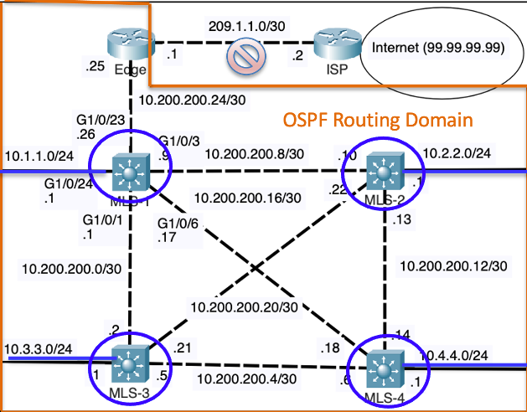

You might have wondered why we did not include our LAN interfaces, the interfaces without a neighbor, as point-to-point. Using the **show ip ospf interface** command on the gig 1/0/24 interface of MLS-1 shows it is the DR and there is no BDR. This is because there are no other routers.



MLS-1# **show ip ospf interface g 1/0/24**

GigabitEthernet1/0/24 is up, line protocol is up

Internet address is 10.1.1.1/24, Area 0

Process ID 1, Router ID 1.1.1.1, Network Type BROADCAST, Cost: 10

Transmit Delay is 1 sec, State DR, Priority 1

Designated Router (ID) 1.1.1.1, Interface address 10.1.1.1

No backup designated router on this network

Timer intervals configured, Hello 10, Dead 40, Wait 40, Retransmit 5

Hello due in 00:00:07

Index 3/3, flood queue length 0

Next 0x0(0)/0x0(0)

Last flood scan length is 1, maximum is 1

Last flood scan time is 0 msec, maximum is 0 msec

Neighbor Count is 0, Adjacent neighbor count is 0

Suppress hello for 0 neighbor(s)

MLS-1#

Since there are no other routers, there is no need for the router to send OSPF Hello packets out this interface every 10 seconds. We can silence this Hello message from being sent using the OSPF **passive-interface** command for that interface.

The **passive-interface** command in OSPF is used to prevent OSPF messages from being sent out through a specified interface, effectively making the interface silent while still participating in the OSPF process. This command helps to secure the OSPF routing domain by blocking unnecessary OSPF adjacencies on interfaces where neighbor relationships are not needed, such as those facing an internal network or end-user segments. Despite stopping OSPF message transmission, the **passive-interface** command does not prevent the router from advertising the network associated with the passive interface to other OSPF neighbors.

Use this command on all routers with LANs and no OSPF neighbors.

MLS-1

MLS-1(config)# **router ospf 1**

MLS-1(config-router)# **passive-interface gig 1/0/24**

MLS-1(config-router)# **exit**

MLS-2



MLS-2(config)# **router ospf 1**

MLS-2(config-router)# **passive-interface gig 1/0/24**

MLS-2(config-router)# **exit**

MLS-3



MLS-3(config)# **router ospf 1**

MLS-3(config-router)# **passive-interface gig 1/0/24**

MLS-3(config-router)# **exit**

MLS-4



MLS-4(config)# **router ospf 1**

MLS-4(config-router)# **passive-interface gig 1/0/24**

MLS-4(config-router)# **exit**

It is crucial not to remove the passive interface from the OSPF network commands or interface-specific OSPF configurations. For example, do not remove the **network 10.1.1.0 0.0.0.255 area 0** command from MLS-1.

Doing so would lead to the router not advertising that network at all. Even though the interface does not send OSPF messages due to being passive, it must still be included in the OSPF configurations to ensure its subnet is properly advertised across the OSPF network. This maintains complete and accurate routing information throughout the OSPF domain, ensuring all reachable subnets are known to other routers in the network.

The passive interface can be verified using the **show ip protocols** command, along with showing that the network is still be advertised by OSPF.



MLS-1# **show ip protocols**

Routing Protocol is "ospf 1"

Outgoing update filter list for all interfaces is not set

Incoming update filter list for all interfaces is not set

Router ID 1.1.1.1

Number of areas in this router is 1. 1 normal 0 stub 0 nssa

Maximum path: 4

Routing for Networks:

10.1.1.0 0.0.0.255 area 0

10.200.200.24 0.0.0.3 area 0

10.200.200.8 0.0.0.3 area 0

10.200.200.16 0.0.0.3 area 0

10.200.200.0 0.0.0.3 area 0

Passive Interface(s):

GigabitEthernet1/0/24

Routing Information Sources:

Gateway Distance Last Update

1.1.1.1 110 00:16:18

2.2.2.2 110 00:16:08

3.3.3.3 110 00:16:09

4.4.4.4 110 00:15:52

10.10.10.10 110 00:22:22

Distance: (default is 110)

MLS-1#

# Campus Network Architecture

For those implementing OSPF as part of their campus network.

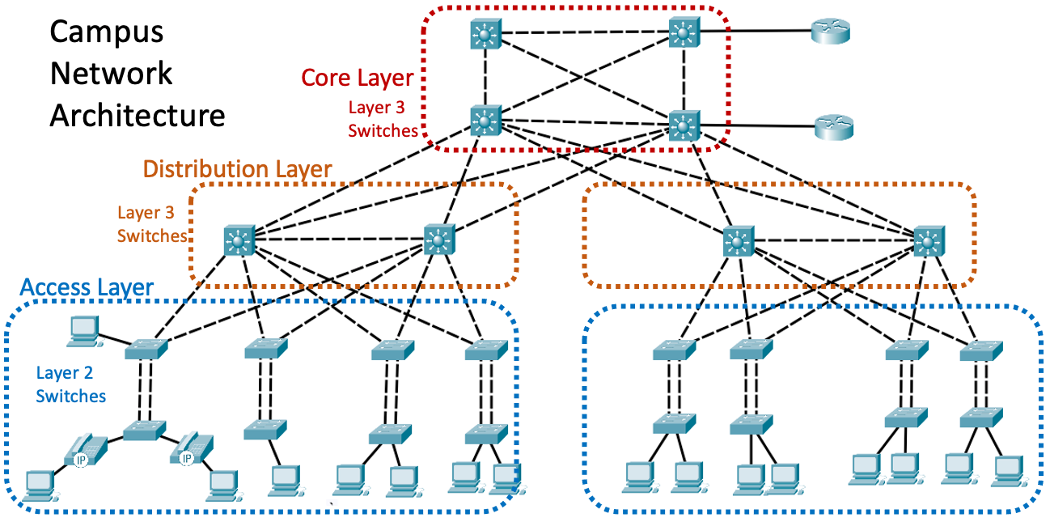 

In a campus network architecture, OSPF can be effectively implemented to manage routing between the core, distribution, and access layers. Our OSPF topology, as previously discussed, can be adapted to fit this hierarchical model, providing scalable and efficient routing.

**Core Layer**

The core layer consists of high-speed Layer 3 switches that form the backbone of the network, ensuring fast and reliable connectivity between different distribution layer switches. In this architecture, the core layer switches run OSPF to dynamically manage and distribute routing information. The core layer provides high-speed, fault-tolerant paths for traffic between the distribution layer switches.

**Distribution Layer**

The distribution layer acts as an intermediary between the core and access layers, aggregating traffic from multiple access layer switches before forwarding it to the core. Distribution switches are also Layer 3 switches that run OSPF. They form OSPF adjacencies with core switches and other distribution switches, ensuring optimal path selection and redundancy. The use of OSPF between distribution switches ensures efficient inter-VLAN routing and load balancing, improving network performance and reliability.

In summary, implementing OSPF in a campus network architecture involves configuring OSPF on core and distribution layer switches to dynamically manage routing information and ensure optimal path selection. This approach leverages OSPF’s scalability and efficiency, providing a robust and flexible routing solution for large, hierarchical network environments.

# Final Verification Commands

Here Is a sample of some of the final verification commands. The output from these command has been explained at various times during in this lab.



MLS-1# **show ip route ospf**

10.0.0.0/8 is variably subnetted, 11 subnets, 2 masks

O 10.2.2.0 [110/20] via 10.200.200.10, 01:34:31, GigabitEthernet1/0/3

O 10.3.3.0 [110/20] via 10.200.200.2, 02:06:03, GigabitEthernet1/0/1

O 10.4.4.0 [110/20] via 10.200.200.18, 00:51:58, GigabitEthernet1/0/6

O 10.200.200.4 [110/20] via 10.200.200.2, 00:51:58, GigabitEthernet1/0/1

[110/20] via 10.200.200.18, 00:51:58, GigabitEthernet1/0/6

O 10.200.200.12 [110/20] via 10.200.200.18, 00:51:58, GigabitEthernet1/0/6

[110/20] via 10.200.200.10, 00:51:58, GigabitEthernet1/0/3

O 10.200.200.20 [110/20] via 10.200.200.2, 00:52:18, GigabitEthernet1/0/1

[110/20] via 10.200.200.10, 00:52:18, GigabitEthernet1/0/3

O*E2 0.0.0.0/0 [110/1] via 10.200.200.25, 00:52:18, GigabitEthernet1/0/23

MLS-1# **show ip ospf neighbor**

Neighbor ID Pri State Dead Time Address Interface

3.3.3.3 0 FULL/ - 00:00:39 10.200.200.2 GigabitEthernet1/0/1

2.2.2.2 0 FULL/ - 00:00:17 10.200.200.10 GigabitEthernet1/0/3

4.4.4.4 0 FULL/ - 00:00:32 10.200.200.18 GigabitEthernet1/0/6

10.10.10.10 0 FULL/ - 00:00:32 10.200.200.25 GigabitEthernet1/0/23

MLS-1# **show ip protocols**

Routing Protocol is "ospf 1"

Outgoing update filter list for all interfaces is not set

Incoming update filter list for all interfaces is not set

Router ID 1.1.1.1

Number of areas in this router is 1. 1 normal 0 stub 0 nssa

Maximum path: 4

Routing for Networks:

10.1.1.0 0.0.0.255 area 0

10.200.200.24 0.0.0.3 area 0

10.200.200.8 0.0.0.3 area 0

10.200.200.16 0.0.0.3 area 0

10.200.200.0 0.0.0.3 area 0

Passive Interface(s):

GigabitEthernet1/0/24

Routing Information Sources:

Gateway Distance Last Update

1.1.1.1 110 00:16:18

2.2.2.2 110 00:16:08

3.3.3.3 110 00:16:09

4.4.4.4 110 00:15:52

10.10.10.10 110 00:22:22

Distance: (default is 110)

MLS-1# **show ip ospf inter g 1/0/1**

GigabitEthernet1/0/1 is up, line protocol is up

Internet address is 10.200.200.1/30, Area 0

Process ID 1, Router ID 1.1.1.1, Network Type POINT-TO-POINT, Cost: 10

Transmit Delay is 1 sec, State POINT-TO-POINT,

Timer intervals configured, Hello 10, Dead 40, Wait 40, Retransmit 5

Hello due in 00:00:00

Index 1/1, flood queue length 0

Next 0x0(0)/0x0(0)

Last flood scan length is 1, maximum is 1

Last flood scan time is 0 msec, maximum is 0 msec

Neighbor Count is 1 , Adjacent neighbor count is 1

Adjacent with neighbor 3.3.3.3

Suppress hello for 0 neighbor(s)

MLS-1# **show ip ospf database**

OSPF Router with ID (1.1.1.1) (Process ID 1)

Router Link States (Area 0)

Link ID ADV Router Age Seq# Checksum Link count

1.1.1.1 1.1.1.1 1123 0x80000024 0x00497f 9

10.10.10.10 10.10.10.10 1487 0x8000000c 0x004725 2

3.3.3.3 3.3.3.3 1114 0x8000001b 0x00e2a2 7

2.2.2.2 2.2.2.2 1113 0x8000001d 0x00f572 7

4.4.4.4 4.4.4.4 1097 0x8000001b 0x00b9b3 7

Type-5 AS External Link States

Link ID ADV Router Age Seq# Checksum Tag

0.0.0.0 10.10.10.10 232 0x80000008 0x00e1c1 1

# Final Running Configs

Top of Form

**Edge#show running-config**

version 15.4

!

hostname Edge

!

no ip domain-lookup

!

interface GigabitEthernet0/0/0

ip address 10.200.200.25 255.255.255.252

ip ospf network point-to-point

ip ospf priority 1

duplex auto

speed auto

!

interface GigabitEthernet0/0/1

ip address 209.1.1.1 255.255.255.252

duplex auto

speed auto

!

router ospf 1

router-id 10.10.10.10

log-adjacency-changes

auto-cost reference-bandwidth 10000

network 10.200.200.24 0.0.0.3 area 0

default-information originate

!

ip route 0.0.0.0 0.0.0.0 209.1.1.2

ip route 10.0.0.0 255.0.0.0 Null0

!

line con 0

exec-timeout 0 0

logging synchronous

!

end

**MLS-1#show running-config**

version 16.3.2

!

hostname MLS-1

!

!

ip routing

!

no ip domain-lookup

!

interface GigabitEthernet1/0/1

no switchport

ip address 10.200.200.1 255.255.255.252

ip ospf network point-to-point

ip ospf priority 1

duplex auto

speed auto

!

interface GigabitEthernet1/0/2

!

interface GigabitEthernet1/0/3

no switchport

ip address 10.200.200.9 255.255.255.252

ip ospf network point-to-point

ip ospf hello-interval 5

ip ospf dead-interval 20

ip ospf priority 1

duplex auto

speed auto

!

interface GigabitEthernet1/0/6

no switchport

ip address 10.200.200.17 255.255.255.252

ip ospf network point-to-point

ip ospf priority 1

duplex auto

speed auto

!

interface GigabitEthernet1/0/23

no switchport

ip address 10.200.200.26 255.255.255.252

ip ospf network point-to-point

ip ospf priority 1

duplex auto

speed auto

!

interface GigabitEthernet1/0/24

no switchport

ip address 10.1.1.1 255.255.255.0

duplex auto

speed auto

!

router ospf 1

router-id 1.1.1.1

log-adjacency-changes

passive-interface GigabitEthernet1/0/24

auto-cost reference-bandwidth 10000

network 10.1.1.0 0.0.0.255 area 0

network 10.200.200.24 0.0.0.3 area 0

network 10.200.200.8 0.0.0.3 area 0

network 10.200.200.16 0.0.0.3 area 0

network 10.200.200.0 0.0.0.3 area 0

!

line con 0

exec-timeout 0 0

logging synchronous

!

**MLS-2#show running-config**

version 16.3.2

!

hostname MLS-2

!

ip routing

!

no ip domain-lookup

!

interface GigabitEthernet1/0/3

no switchport

ip address 10.200.200.10 255.255.255.252

ip ospf network point-to-point

ip ospf hello-interval 5

ip ospf dead-interval 20

ip ospf priority 1

duplex auto

speed auto

!

interface GigabitEthernet1/0/4

no switchport

ip address 10.200.200.13 255.255.255.252

ip ospf network point-to-point

ip ospf priority 1

duplex auto

speed auto

!

interface GigabitEthernet1/0/5

no switchport

ip address 10.200.200.22 255.255.255.252

ip ospf network point-to-point

ip ospf priority 1

duplex auto

speed auto

!

interface GigabitEthernet1/0/24

no switchport

ip address 10.2.2.1 255.255.255.0

duplex auto

speed auto

!

router ospf 1

router-id 2.2.2.2

log-adjacency-changes

passive-interface GigabitEthernet1/0/24

auto-cost reference-bandwidth 10000

network 10.2.2.0 0.0.0.255 area 0

network 10.200.200.8 0.0.0.3 area 0

network 10.200.200.20 0.0.0.3 area 0

network 10.200.200.12 0.0.0.3 area 0

!

line con 0

exec-timeout 0 0

logging synchronous

**MLS-3#show running-config**

version 16.3.2

!

hostname MLS-3

!

ip routing

!

no ip domain-lookup

!

interface GigabitEthernet1/0/1

no switchport

ip address 10.200.200.2 255.255.255.252

ip ospf network point-to-point

ip ospf priority 1

duplex auto

speed auto

!

interface GigabitEthernet1/0/2

no switchport

ip address 10.200.200.5 255.255.255.252

ip ospf network point-to-point

ip ospf priority 1

duplex auto

speed auto

!

interface GigabitEthernet1/0/5

no switchport

ip address 10.200.200.21 255.255.255.252

ip ospf network point-to-point

ip ospf priority 1

duplex auto

speed auto

!

interface GigabitEthernet1/0/24

no switchport

ip address 10.3.3.1 255.255.255.0

duplex auto

speed auto

!

router ospf 1

router-id 3.3.3.3

log-adjacency-changes

passive-interface GigabitEthernet1/0/24

auto-cost reference-bandwidth 10000

network 10.3.3.1 0.0.0.0 area 0

network 10.200.200.2 0.0.0.0 area 0

network 10.200.200.5 0.0.0.0 area 0

network 10.200.200.21 0.0.0.0 area 0

!

line con 0

exec-timeout 0 0

logging synchronous

**MLS-4#show running-config**

version 16.3.2

!

hostname MLS-4

!

no ip cef

ip routing

!

no ip domain-lookup

!

interface GigabitEthernet1/0/2

no switchport

ip address 10.200.200.6 255.255.255.252

ip ospf network point-to-point

ip ospf priority 1

ip ospf 1 area 0

duplex auto

speed auto

!

interface GigabitEthernet1/0/4

no switchport

ip address 10.200.200.14 255.255.255.252

ip ospf network point-to-point

ip ospf priority 1

ip ospf 1 area 0

duplex auto

speed auto

!

interface GigabitEthernet1/0/6

no switchport

ip address 10.200.200.18 255.255.255.252

ip ospf network point-to-point

ip ospf priority 1

ip ospf 1 area 0

duplex auto

speed auto

!

interface GigabitEthernet1/0/24

no switchport

ip address 10.4.4.1 255.255.255.0

ip ospf 1 area 0

duplex auto

speed auto

!

router ospf 1

router-id 4.4.4.4

log-adjacency-changes

passive-interface GigabitEthernet1/0/24

auto-cost reference-bandwidth 10000

!

line con 0

exec-timeout 0 0

logging synchronous

!

line aux 0

!

line vty 0 4

login